|  |
| --- |
|  |
| **CANCER IN TENNESSEE** |
| **2008-2012** |
|  |
| **January 2016**  **cid:image001.png@01D0AAAF.AF3502B0**  **Division of Policy, Planning, and Assessment**  **Office of Cancer Surveillance** |
|  |

Department of Health. Authorization No. 343837, 01/15 Website Only

|  |
| --- |
| This document presents cancer incidence and mortality information for the entire state of Tennessee focusing on the five-year period between 2008 and 2012, with comparisons to national rates. The report is made possible through data collected by the Tennessee Cancer Registry (TCR) as well as cancer registries nationwide. The TCR is dedicated to the collection and use of quality data for the purpose of decreasing the incidence and mortality of cancer in Tennessee. |

**Prepared by:**

* Jake Richards, MBA
* Martin Whiteside, DC, PhD, MSPH

**Acknowledgments**

The Office of Cancer Surveillance acknowledges the contributions of the following organizations and individuals in making the publication of this report possible:

* Cancer registrars from healthcare facilities throughout the State of Tennessee who completed the large majority of cancer abstracts available in the TCR database.
* The staff of the Office of Health Statistics, Tennessee Department of Health (TDH), for providing cancer mortality data.
* The staff of the Tennessee Cancer Registry (TCR); Office of Cancer Surveillance; Division of Policy, Planning and Assessment; TDH. These dedicated individuals labored tirelessly to ensure the quality and completeness of TCR data.

**SUGGESTED CITATION**

Richards J.E., Whiteside M.A. *Cancer in Tennessee. 2008-2012*. Tennessee Department of Health: Division of Policy, Planning & Assessment – Office of Cancer Surveillance. Nashville, Tennessee, December 2015.

**COPYRIGHT INFORMATION**

This publication was supported by cooperative agreement grant number 5U58DP003901 from the Centers for Disease Control and Prevention (CDC). Its contents are solely the responsibility of the authors and do not necessarily represent the views or opinions of the CDC. All materials in this report are in the public domain and may be reproduced or copied without permission; citation as to source, however, is appreciated.

Contents

Executive Summary vi

Preface vii

History of the Tennessee Cancer Registry vii

Purpose of the Tennessee Cancer Registry vii

Confidentiality of Patient Data viii

Tennessee Cancer Registry viii

Overview - 1 -

Introduction - 1 -

Impact of Cancer - 1 -

Tennessee Demographics - 2 -

Cancer Incidence and Mortality in Tennessee - 2 -

Regional and County Differences in Cancer - 2 -

10 Most Common Sites of Cancer Incidence - 3 -

10 Most Common Sites of Cancer Mortality - 3 -

Most Common Cancers in Tennessee, 2008-2012 - 4 -

Lung Cancer - 4 -

Prostate Cancer - 4 -

Female Breast Cancer - 5 -

Colorectal Cancer - 5 -

Melanoma of the Skin - 6 -

Pancreatic Cancer - 6 -

Childhood Cancer - 7 -

Cancer Site Specific Webpages - 8 -

National Organizations and Websites - 9 -

Top Five Leading Causes of Death in Tennessee, 2012 - 10 -

Tennessee Compared to the United States - 11 -

Cancer Mortality Trend, 1992-2012 - 11 -

Tennessee Cancer Incidence and Mortality Rankings, 2008-2012 - 12 -

Types of Cancers in Tennessee, 2008-2012 - 14 -

Leading Causes of Cancer Incidence, 2008-2012 - 14 -

Leading Causes of Cancer Mortality, 2008-2012 - 17 -

Cancer Incidence and Mortality in Tennessee, 2008-2012 - 20 -

Cancer Incidence and Mortality, All Sites Combined, Tennessee, 2008-2012 - 20 -

Years of Potential Life Lost to Cancer, Tennessee, 2008-2012 - 24 -

Common Cancers in Tennessee, 2008-2012 - 29 -

Cancer of Lung and Bronchus - 29 -

Cancer of Prostate - 31 -

Cancer of Breast Among Females - 33 -

Cancer of Colon and Rectum - 35 -

Melanoma of the Skin - 37 -

Cancer of Pancreas - 39 -

Childhood Cancer in Tennessee, 2008-2012 - 41 -

Childhood Cancer by Gender and Race, and Time Trend - 41 -

Childhood Cancer by Stage - 42 -

Leading Causes of Childhood Cancer Incidence - 43 -

Cancer Risk Factor Prevalence in Tennessee, 2012 - 44 -

Cancer Screening Prevalence, Tennessee - 44 -

Cigarette Smoking Prevalence Among Adults Over 18 Years of age, Tennessee, 1995-2012 - 45 -

Appendices - 47 -

Appendix I. Incidence and Mortality of Common Cancers - 47 -

Appendix II. Cancer Incidence and Mortality, By Site, Tennessee, 2008-2012 - 53 -

Appendix III. Cancer Incidence and Mortality, All Sites Combined, by Gender, Race and Resident Region, Tennessee 2008-2012 - 56 -

Appendix IV. Cancer Incidence and Mortality, All Sites Combined, by Resident County, Tennessee, 2008-2012 - 57 -

Appendix V. Lung and Bronchus Cancer Incidence and Mortality by Resident County, Tennessee, 2008-2012 - 60 -

Appendix VI. Prostate Cancer Incidence and Mortality by Resident County, Tennessee, 2008-2012 - 63 -

Appendix VII. Female Breast Cancer Incidence and Mortality by Resident County, Tennessee, 2008-2012 - 66 -

Appendix VIII. Colorectal Cancer Incidence and Mortality by Resident County, Tennessee, 2008-2012 - 69 -

Appendix IX. Melanoma of the Skin Incidence and Mortality by Resident County, Tennessee, 2008-2012 - 72 -

Appendix X. Pancreatic Cancer Incidence and Mortality by Resident County, Tennessee, 2008-2012 - 75 -

Appendix XI. Cancer Incidence and Mortality, Children 0-19 Years, by Resident County, Tennessee, 2008-2012 - 78 -

Appendix XII. Incidence and Mortality of Common Cancers, Three-Year Moving Average, Tennessee, 2008-2012 - 81 -

Appendix XIII. County Maps of Incidence and Mortality Rates of All Cancers and Common Cancers - 82 -

1. Tennessee Counties and Regional Groupings - 82 -

2. Age-adjusted Cancer Incidence and Mortality Rates by Resident County, All Sites Combined, Tennessee, 2008-2012 - 83 -

3. Age-adjusted Cancer Incidence and Mortality Rates by Resident County, Lung and Bronchus, Tennessee, 2008-2012 - 84 -

4. Age-adjusted Cancer Incidence and Mortality Rates by Resident County, Prostate, Tennessee, 2008-2012 - 85 -

5. Age-adjusted Cancer Incidence and Mortality Rates by Resident County, Female Breast, Tennessee, 2008-2012 - 86 -

6. Age-adjusted Cancer Incidence and Mortality Rates by Resident County, Colon and Rectum, Tennessee, 2008-2012 - 87 -

7. Age-adjusted Cancer Incidence and Mortality Rates by Resident County, Melanoma of the Skin, Tennessee, 2008-2012 - 88 -

8. Age-adjusted Cancer Incidence and Mortality Rates by Resident County, Pancreas, Tennessee, 2008-2012 - 89 -

Tables - 91 -

Table 1. Number of Deaths and Years of Potential Life Lost, By Gender and Race, Tennessee, 2008-2012 - 91 -

Table 2. Number of Deaths and Years of Potential Life Lost, by Common Cancer Site, Tennessee, 2008-2012 - 91 -

Table 3. Number of Deaths and Years of Potential Life Lost, by Other Common Cancer Site, Tennessee, 2008-2012 - 91 -

Technical Notes - 92 -

Statistical Methods - 92 -

Software Used for Calculation - 92 -

Explanation of Terms - 93 -

Data Sources - 97 -

References - 98 -

## Executive Summary

The Tennessee Department of Health (TDH) Office of Cancer Surveillance (OCS) publishes the Annual Cancer Report to provide information about cancer incidence, mortality, stage, and screening in Tennessee. This Annual Report provides a snapshot of the cancer burden in Tennessee during the five year period between 2008 and 2012. This publication is intended to serve as a record of the current status of cancer in Tennessee and a tool for cancer healthcare planning.

Cancer continues to be the second leading cause of death in Tennessee, exceeded only by diseases of the heart. From 2008 to 2012, 169,031 new cancer cases were diagnosed among Tennessee residents and 67,120 deaths were recorded as the underlying cause of death in Tennessee residents. The five year age-adjusted incidence rate in Tennessee for 2008-2012 was 475.6 cases per 100,000 Tennesseans, while the age-adjusted mortality rate was 191.9 per 100,000 Tennesseans. In 2012, 34,093 new cancer cases were diagnosed and 13,630 deaths were recorded as the underlying cause of death in Tennessee residents.

Nationally, Tennessee had the 17th highest cancer incidence rate and the 7th highest cancer mortality rate for the overall population for the five year period between 2008 and 2012. Among blacks, Tennessee had the 19th highest cancer incidence and the 3rd highest cancer mortality rate in the nation. Among whites, Tennessee had the 17th highest cancer incidence and the 6th highest cancer mortality rate. Compared to residents of other states, Tennessee residents experience a disproportionately higher share of the U.S. cancer burden in terms of both new cancer cases and cancer deaths.

From 2008 to 2012, the five most common cancer sites in Tennessee women were the breast, lung, colon and rectum, corpus and uterus (Not Otherwise Specified), and the thyroid. The five most common cancer sites recorded as an underlying cause of death for Tennessee women were the lung, breast, colon and rectum, pancreas, and ovary. During the same five-year time period, the five most common cancer sites in Tennessee men were the prostate, lung, colon and rectum, urinary bladder, and melanoma of the skin. For men, the five most common cancer sites recorded as an underlying cause of death were the lung, colon and rectum, prostate, pancreas, and liver.

Among the United States, Tennessee has the 5th highest lung and bronchus cancer incidence rate, the 34th highest female breast cancer incidence rate, the 12th highest prostate cancer incidence rate, the 18th highest colorectal incidence rate, 42nd highest pancreatic cancer incidence rate, and the 32nd highest skin cancer rate. Conversely, Tennessee has the 4th highest lung and bronchus cancer mortality rate, the 10th highest female breast cancer mortality rate, the 25th highest prostate cancer mortality rate, the 8th highest colorectal mortality rate, the 38th highest pancreatic cancer mortality rate, and the 16th highest skin cancer mortality rate amongst the United States. Among the United States, Tennessee ranks as 45th unhealthiest states overall; physical inactivity, obesity and smoking were ranked 49th, 47th, and 46th respectively.

# Preface

This report contains cancer incidence and mortality data for the entire state of Tennessee from 2008 through 2012, with some comparisons to national rates. Data collected by the Tennessee Cancer Registry (TCR) as well as cancer registries nationwide made the creation of this report possible. The report published by TCR is meant to serve as a reference for researchers and the general public. For additional information and publications from the TCR, we encourage you to visit our website at <http://tn.gov/health/section/tcr>.

## History of the Tennessee Cancer Registry

The Tennessee Cancer Registry, which was established in 1983 by the Department of Health, is legislatively mandated to collect information on all reportable cancer diagnoses in Tennessee, including non-residents diagnosed and/or treated in Tennessee. CDC funding for the TCR began in 1997 and the first diagnosis year for which cancer cases were reportable to CDC was 1999. The TCR is currently a gold-certified registry, the highest level of certification by the North American Association of Central Cancer Registries. The TCR has met national standards of data completeness and quality since the 2004 diagnosis year. It should be noted that data collected during the 2004 diagnosis year was less than 95% complete, the level needed to attain gold-certified status, whereas 2005-2012 data exceeded the 95% completeness threshold level.

In collaboration with local health care facilities and cancer registrars, TCR staff members identify incidence cases of cancer through routine, systematic review of pathology reports, medical records, radiation therapy records, hospital discharge lists, and state vital records. Information regarding patient characteristics, cancer diagnosis, and first-course treatment is ascertained primarily from specific statements in the medical record and other sources such as death certificates and physician reports. The cancer data in this report is dynamic and it is possible that even after the standard reporting delay, a few cases may be reported, which may have a minor impact on the most recent year of diagnosis.

## Purpose of the Tennessee Cancer Registry

* To collect accurate information on cancer cases diagnosed and/or treated in Tennessee annually.
* To increase awareness of cancer in Tennessee.
* To promote and assist hospital cancer registries in each facility with coding of cancer abstracts.
* To provide information to the public regarding cancer incidence and mortality in Tennessee.
* To serve as a data repository for those requesting information on cancer, its effects, treatment, risk factors, and prevention.
* To support epidemiological research into the cause, distribution, prevention, and treatment of cancer.

## Confidentiality of Patient Data

All information obtained on patients shall be considered extremely classified. Absolutely no personal or identifying information, such as name or social security number, can be released to researchers unless Institutional Review Board (IRB) approval is obtained. All information shall be used solely for statistical, scientific and medical research purposes and shall be held strictly confidential by the TCR.

## Tennessee Cancer Registry

As an affiliate of the Tennessee Department of Health, the Tennessee Cancer Registry would like to give special thanks to the Centers for Disease Control and Prevention for their financial support. Furthermore, the TCR would like to thank the following for their professional support:

**John J. Dreyzehner,** MD, MPH, FACOEM, Commissioner

**David Reagan,** MD, PhD, Chief Medical Officer

**Bruce Behringer,** MPH, Deputy Commissioner

**Lori B. Ferranti,** PhD, MBA, MSN, Director, Division of Policy, Planning & Assessment

**Martin A. Whiteside,** DC, PhD, MSPH, Director, Office of Cancer Surveillance

***The mission of the Tennessee Department of Health is to protect, promote and improve the health and prosperity of people in Tennessee.***

State of Tennessee

Department of Health

Division of Policy, Planning and Assessment

Office of Cancer Surveillance

Tennessee Cancer Registry

710 James Robertson Parkway

Nashville, Tennessee 37243

Phone: (615)741-5548 or 800-547-3558

***The Tennessee Cancer Registry is dedicated to the collection and use of quality data***

***for the purpose of decreasing the incidence and mortality of cancer in Tennessee.***

# Overview

## 

## Introduction

Cancer is a group of more than 100 diseases characterized by uncontrolled growth and spread of abnormal cells. It is the second leading cause of death nationally and in Tennessee (TN). Anyone can develop cancer at any time in their life, but individuals 55 years of age and older are at a higher risk of developing cancer and this cohort represents 78% of all cancer diagnoses in the United States (U.S.) during the period 2008-12. About two-thirds of all cancer cases could potentially be prevented with better lifestyle choices (e.g. increasing physical activity, better nutrition, and not using tobacco products). Diagnosing cancer early through regular cancer screening is also an important method of cancer prevention. Currently accepted screening practices, when performed on a regular basis and in a suitably targeted population, can successfully detect breast, colorectal, uterine cervix, prostate, and melanoma skin cancers. Other cancers such as thyroid, testicular, ovarian, and oral cancers can be identified through regular health examinations.

## Impact of Cancer

On average, two out of every five individuals in the U.S. will contract some type of cancer in their lifetime. Males have a 43.3% probability of developing cancer in their lifetime, while females have a 37.8% probability of developing cancer in their lifetime (Fay, 2004). One in four males (22.8%) and one out of five females (19.3%) are at risk of dying from cancer in their lifetime. The following table lists lifetime risks of developing and dying from certain cancers for males in the U.S. from 2009 to 2011 in decreasing order:

*Note*. Adapted from the [Lifetime Risk of Developing or Dying From](http://www.cancer.org/cancer/cancerbasics/lifetime-probability-of-developing-or-dying-from-cancer), by The American Cancer Society, 2014.

The following table lists lifetime risks of developing and dying from certain cancers for females in the U.S. from 2009 to 2011 in decreasing order:

*Note*. Adapted from the [Lifetime Risk of Developing or Dying From](http://www.cancer.org/cancer/cancerbasics/lifetime-probability-of-developing-or-dying-from-cancer), by The American Cancer Society, 2014.

More than half (55.1%) of all cancer cases with known stage information were diagnosed at early stages, when treatment is usually more effective. Nearly 563,000 years of potential life were lost in TN residents due to premature cancer deaths during the five-year reporting period; therefore, on average, each person who died of cancer during the five-year period died 8.4 years earlier than the average lifespan (75 years of age as used in this report). From 2008 through 2012, 21,546 black individuals and 145,134 white individuals contracted cancer and during that same time period 9,473 black individuals and 57,215 white individuals died due to cancer.

The direct medical costs (total of all health care expenditures) for cancer in the U.S. in 2010 were $124.6 billion, or almost $80,561 per cancer diagnosis. By 2020, cancer costs could reach $157.8 billion (in 2010 dollars), based only on increases in population; however, if costs of cancer care also increase annually by 2%, the total cost for cancer care in 2020 could reach as high as $186.7 billion. The cancer sites with the highest costs in 2010 dollars are: breast cancer ($16.5 billion), followed by colorectal cancer ($14.1 billion), lymphoma ($12.1 billion), lung cancer ($12.1 billion), and prostate cancer ($11.9 billion) (Mariotto, 2011).

## Tennessee Demographics

At the time of the 2010 Census, the TN population was estimated to be 6.35 million people and females represented 51.3% of this total, while males made up the remainder. It is also important to note that from 2000 to 2010, the TN population grew by about 11.5% (United States Census Bureau, 2012). With regards to race, more than three quarters (78.4%) of the TN population was white, 16.7% of the population was black, and the remaining 4.9% of the TN population was classified as ‘Other’. The ‘Other’ grouping includes: American Indian, Alaska Native, Asian, Native Hawaiian, and Pacific Islander racial groups. With regards to age, 59.6% of the TN population was less than forty-five years of age, 26.8% of the population was between forty-five and sixty-four years of age, and 13.6% of the population was over 65 years of age.

## Cancer Incidence and Mortality in Tennessee

During 2008-2012, a total of 169,031 new cases of invasive cancer were diagnosed among TN residents, resulting in an incidence rate of 475.6 per 100,000; this number excludes all *in situ* cases except for urinary bladder. There were 67,120 deaths with cancer recorded as the underlying cause of death in TN residents during the same time period, resulting in a mortality rate of 191.9 per 100,000. In 2012, 34,093 new cancer cases were diagnosed and 13,630 deaths were attributed to cancer in TN. From 2008 to 2012, cancer incidence and mortality rates decreased by 4.9% and 5.3%, respectively, and these changes were statistically significant.

## Regional and County Differences in Cancer

Cancer incidence and mortality rates varied by region and by county. The 95 counties in TN are grouped into 8 regions by the TN Department of Health (TDH): Northwest, Southwest, South Central, Mid-Cumberland, Upper Cumberland, Southeast, East and Northeast (see Appendix III). The East region had the highest overall cancer incidence rate (496.8), whereas the Northwest (462.5), Southwest (466.2), and South Central (467.5) regions displayed the lowest. The Northwest region displayed the highest overall cancer mortality rate (213.1), whereas the Southeast (184.4) and Mid-Cumberland (185.3) regions displayed the lowest. Males had higher incidence and mortality rates than females in all regions.

At the county level, Lewis (544.2), Cheatham (543.1), Scott (540.4), Rhea (540.2), and Benton (539.9) counties had the highest overall cancer incidence rates. The lowest overall cancer incidence rates were observed in Moore (411.1), Chester (411.3), Dyer (411.6), and Lake (416.0) counties. The highest overall cancer mortality rates were observed in Scott (253.2), Stewart (237.6), Sequatchie, (235.2) Benton (235.0), and Hancock (232.1) counties. The lowest overall cancer mortality rates were observed in Williamson (141.6), Moore (144.3), Bledsoe (159.3), Loudon (163.3), and Chester (165.2) counties.

## 10 Most Common Sites of Cancer Incidence

The following 10 cancer sites accounted for the greatest number of new cancer cases, in decreasing order, in TN and the United States during the period 2008-2012:  Data Source

## 10 Most Common Sites of Cancer Mortality

The following 10 cancers accounted for the greatest number of deaths, in decreasing order, in TN and the U.S. in 2008-2012 in decreasing order were as follows:



Data Source

# Most Common Cancers in Tennessee, 2008-2012

## 

## Lung Cancer

From 2008 through 2012, lung cancer accounted for 16.6% of all new cancer cases and almost a third (32.3%) of all cancer mortalities. The lung cancer incidence rate decreased by 5.2% from 2008 to 2012 and this change was statistically significant; although, it is important to note that the number of lung cancer cases increased from 5,465 in 2008 to 5,683 in 2012, a 4.0% increase. Additionally, the lung cancer mortality rate decreased by 8.0% from 2008-2012 and this change was statistically significant. TN had the 5th highest incidence rate and the 4th highest mortality rate in the U.S from 2008-2012.

Lung cancer is the leading cause of cancer incidence (28,002 cases) and mortality (21,661 deaths) in TN. Only 22.2% of lung cancer cases with known stage information were diagnosed in early stages. Males had higher incidence and mortality rates than females. White females had higher incidence and mortality rates than black females and black males had higher incidence and mortality rates than white males. The mortality-to-incidence ratio for lung cancer was 0.78, making it the 2nd deadliest cancer out of TN’s 10 most common cancers (See Appendix II). In recent years, the National Lung Screening Trial has illustrated that a lung cancer screening test can help lower the risk of dying from this disease in certain individuals (NLSTRT, 2011).

## Prostate Cancer

During the 2008-2012, prostate cancer accounted for 25.9% of new male cancer cases and 7.8% of male deaths due to cancer. Prostate cancer incidence rates decreased from 2008 to 2012 by 25.2% and this change was statistically significant. The number of prostate cancer cases decreased from 4,886 cases in 2008 to 4,178 cases in 2012, a 14.5% decrease. Mortality rates also decreased from 2008 to 2012 by 17.6% and this was statistically significant. TN had the 13th highest incidence rate and the 25th highest mortality rate in the U.S. from 2008-2012.

Prostate cancer is the leading cause of cancer incidence (22,970 cases) and the 3rd leading cause of cancer mortality (2,871 cases) in TN males. About 85% (84.9%) of cases with known stage information are diagnosed at early stages, which is perhaps partially attributable to prostate cancer screening methods and to the slow progressive course prostate cancer typically displays compared to most other cancers. Black males are disproportionately affected by this disease compared to white males; black men experience a mortality rate that is almost 3 times as high as that for white men (See Cancer of Prostate). Effective screening methods and treatment options may have contributed to the low mortality-to-incidence ratio of prostate cancer (0.17).

## Female Breast Cancer

From 2008 through 2012, breast cancer represented 28.7% of new female cancer cases and 14.3% of female cancer deaths. Both female breast cancer incidence and mortality rates remained stable over the 5-year period covered by this report. However, breast cancer incidence slightly increased from 4,683 cases in 2011 to 4,767 cases in 2012. In 2012, there were 905 deaths due to breast cancer. TN females experienced the 33rd highest breast cancer incidence rate and the 11th highest breast cancer mortality rate in the U.S from 2008-2012.

Breast cancer is the leading cause of cancer incidence (23,035 cases) and the 2nd leading cause of cancer mortality (4,366 cases) in TN females. Almost 70% (69.9%) of new cases with known stage information are diagnosed at early stages when treatment is more effective; the high percentage of early stage breast cancer can be attributable to screening. Incidence rates tend to be comparable in black and white women; however, black women have a mortality rate that is 60.4% higher than that of white women. It is important to note that black females are more likely than white females to be diagnosed with breast cancer in the late stages. Early detection and effective treatment options contributed to the low mortality-to-incidence ratio of breast cancer (0.18).

## Colorectal Cancer

During 2008-2012, colorectal cancer accounted for 9.0% of all new cancer cases and 9.0% of all cancer deaths. Colorectal cancer incidence rates decreased by 13.9% from 2008 to 2012 and the annual percent change was statistically significant. During the same time period, the colorectal cancer mortality rates declined by 11.6% and the annual percent change was statistically significant. TN experienced the 19th highest incidence rate and the 8th highest mortality rate in the U.S. for colorectal cancer from 2008-2012.

Colorectal cancer is the 4th leading cause of cancer incidence (15,223 cases) and the 2nd leading cause of cancer mortality (6,038 cases) in TN. A little less than half (45.1%) of the cases with known stage information are diagnosed at early stages in TN. Black males and black females experience statistically significantly greater incidence and mortality rates for this cancer compared to white males and white females. A slightly higher percentage of black patients were diagnosed at late stages than whites and this difference was statistically significant. Regular colorectal cancer screening can prevent new cases and find colorectal cancer early, when it is highly curable. The main screening exams used for colorectal cancer are the colonoscopy and sigmoidoscopy.

## Melanoma of the Skin

From 2008 through 2012, melanoma of the skin represented 4.2% of all new cancer cases and a mere 1.6% of all cancer deaths. Melanoma incidence and mortality were generally stable over the 5-year period covered by this report; however, there was an unexplained 25.1% increase in the number of cases from 2008 to 2009 (See Melanoma of Skin). Melanoma is the 5th leading cause of cancer incidence (7,164 cases) in TN; however, the total number of deaths from melanoma of the skin are low (1,061 cases). TN experienced the 32nd highest incidence rate and the 16th highest mortality rate in the U.S from 2008-2012.

Cancer screening is very effective at diagnosing melanoma in its early stages; most skin cancers can be found early with skin exams. 90.3% of all new cases in TN during 2008-2012 were diagnosed at early stages. White females experience incidence rates that are 20 times higher than black females. However, blacks experience a much higher mortality-incidence ratio for this disease, i.e. black patients survive for a much shorter time than white patients. This is at least partially attributable to the fact that blacks are three times more likely than whites to be diagnosed at late stages for this cancer.

## Pancreatic Cancer

From 2008-2012, pancreatic cancer accounted for 4,168 cases or 2.5% of all new cancer cases. During the same period, pancreatic cancer was responsible for 3,857 deaths or 5.7% of all cancer deaths in TN. Pancreatic cancer is the 12th leading cause of cancer incidence and the 4th leading cause of cancer mortality in TN. From 2008 to 2012, incidence rates for pancreatic cancer decreased by 2.4% and mortality rates decreased by 7.6%, and these changes were statistically significant. TN experienced the 42nd highest pancreatic cancer incidence rate and the 40th highest pancreatic cancer mortality rate in the U.S from 2008-2012.

Pancreatic cancer is the deadliest form of cancer in TN with a mortality-to-incidence ratio of 0.93 and currently there is no effective screening method. The pancreas is so deep inside the body that early tumors are difficult to detect through imaging and can’t be readily palpated by health care professionals during routine physical exams. Thus, only 15.2% of cases with known stage information are diagnosed at early stages in TN. Black males display statistically significantly higher pancreatic cancer incidence and mortality rates compared to black females, white females and white males.

## 

## Childhood Cancer

The distributions of cancers that develop in children are often quite different compared to the distribution of types that occur in adults. Childhood cancers are the result of DNA changes in cells that take place very early in life, sometimes even before birth. Unlike many cancers in adults, childhood cancers are not strongly linked to lifestyle or environmental risk factors (American Cancer Society, 2015).

There were 1,527 new invasive cancer cases and 209 deaths due to cancer in children less than 20 years of age in TN during 2008 and 2012. TN experienced the 30th highest childhood cancer incidence rate and the 6th highest childhood cancer mortality rate in the U.S from 2008-2012. Only 40.3% of all new cases with known stage information are diagnosed at early stages of the disease. Of the 1,527 new invasive cancer cases in children less than 20 years of age in TN from 2008 to 2012, blacks accounted for about one out of every five (18.6%) childhood cancer cases. Whites accounted for three out of every four childhood cancer cases (76.7%) of all childhood cancer cases. The leading cause of cancer incidence in children less than 20 years of age was leukemia, followed by central nervous system (2nd), lymphoma (3rd), melanoma (4th), and soft tissues (5th); these five causes of cancer incidence represented 74.7% of all childhood cancer cases.

The early diagnosis of childhood cancer is often hampered by nonspecific symptoms that are similar to those of more common childhood diseases. There are currently no effective screening methods for childhood-related cancers. In general, white children tend to have a slightly higher cancer incidence rate compared to black children, but the difference is not statistically significant. Over this five year period, the age adjusted incidence rate for childhood cancers was 182.1 per 1,000,000 and the mortality rate was 25.0 per 1,000,000.

## Cancer Site Specific Webpages

More information can be found on the cancers discussed in this report at the American Cancer Society, which include:

|  |  |
| --- | --- |
| **Specific Cancer Site** | **Website** |
| **Lung Cancer** | <http://www.cancer.org/cancer/lungcancer/> |
| **Prostate Cancer** | <http://www.cancer.org/cancer/prostatecancer/> |
| **Breast Cancer** | <http://www.cancer.org/cancer/breastcancer/> |
| **Colorectal Cancer** | <http://www.cancer.org/cancer/colonandrectumcancer/> |
| **Melanoma Skin Cancer** | <http://www.cancer.org/cancer/skincancer-melanoma/> |
| **Pancreatic Cancer** | <http://www.cancer.org/cancer/pancreaticcancer/> |
| **Childhood Cancer** | <http://www.cancer.org/cancer/cancerinchildren/index> |

## National Organizations and Websites

If interested, other sources of information and support include:

|  |  |
| --- | --- |
| **Organization** | **Website** |
| **American Association for Cancer Research (AACR)** | http://www.aacr.org/Pages/Home.aspx |
| **American Cancer Society (ACS)** | http://www.cancer.org/ |
| **American Society of Clinical Oncology (ASCO)** | http://www.asco.org/ |
| **Cancer Research Network (CRN)** | http://crn.cancer.gov/ |
| **Center for Cancer Research (CCR)** | https://ccr.cancer.gov/ |
| **Centers for Disease Control & Prevention (CDC)** | http://www.cdc.gov/cancer/dcpc/data/index.htm |
| **Commission on Cancer (CoC)** | https://www.facs.org/quality-programs/cancer/coc |
| **Conquer Cancer Foundation** | https://www.conquercancerfoundation.org/ |
| **Journal of Clinical Oncology** | http://jco.ascopubs.org/ |
| **National Cancer Informatics Program (NCIP)** | http://cbiit.nci.nih.gov/ncip |
| **National Cancer Institute (NCI)** | http://www.cancer.gov/ |
| **National Comprehensive Cancer Network (NCCN)** | http://www.nccn.org/ |
| **National Program of Cancer Registries (NPCR)** | http://www.cdc.gov/cancer/npcr/ |
| **North American Association of Central Cancer Registries (NAACCR)** | http://www.naaccr.org/ |
| **International Agency for Research on Cancer** | http://www.iarc.fr/ |

# Top Five Leading Causes of Death in Tennessee, 2012

Unintentional Injuries, 6.6%

Unintentional Injuries, 5.4%

Unintentional Injuries, 5.3%

Diabetes Mellitus, 5.5%

Alzheimer’s Disease, 4.1%

Alzheimer ’s Disease, 6.1%

* Heart disease was the leading cause of death for all Tennesseans, claiming 14,228 lives in 2012.
* Heart disease was the leading cause of death among white males and white females, but was the 2nd leading cause of death among black males and black females.
* Cancer was the 2nd leading cause of death for all Tennesseans, claiming 13,630 lives during 2012.
* Cancer was the 1st leading cause of death among black males and black females, and the 2nd leading cause for white males and white females.

Note: CLRD stands for chronic lower respiratory diseases.

Data Source

# Tennessee Compared to the United States

## Cancer Mortality Trend, 1992-2012

Source: National Cancer Institute (NCI). State Cancer Profiles.

Retrieved from <http://statecancerprofiles.cancer.gov/index.html>

* In TN and the U.S., cancer was the second leading cause of death.
* The age-adjusted cancer mortality rate in TN and the U.S. decreased over time, by 15.3% and 22.1%, respectively, from 1992 to 2012.
* In 1992, the TN cancer mortality rate was 2.9% higher than the U.S. rate.
* In 2012, Tennessee’s cancer mortality rate was 12.0% higher than the U.S. rate.
* In 1995, Tennesseans experienced the highest cancer mortality rate, 223.3 per 100,000.
* Since 1995, the cancer mortality rate in TN has dropped by 20.1%.

Data Source

## Tennessee Cancer Incidence and Mortality Rankings, 2008-2012

Source: National Cancer Institute (NCI). State Cancer Profiles.

Retrieved from <http://statecancerprofiles.cancer.gov/index.html>

* Cancer incidence and mortality rates in TN were well above the national average, but incidence and mortality rates have declined by 4.9% and 5.3%, respectively, from 2008 to 2012.
* It should be noted that in TN, blacks (.48) had a higher mortality-to-incidence ratio than whites (.40) in TN, indicating that whites in TN have a longer average survival than blacks in Tennessee.

Source: National Cancer Institute (NCI). State Cancer Profiles. Retrieved from <http://statecancerprofiles.cancer.gov/index.html>

Data Source

##### Tennessee Rankings, CANCER INCIDENCE AND MORTALITY RANKINGS, 2008-2012 Continued

Source: National Cancer Institute (NCI). State Cancer Profiles.

Retrieved from <http://statecancerprofiles.cancer.gov/index.html>

* Among the most common cancers in TN, lung cancer, prostate cancer, and colorectal cancer were significantly higher than the U.S. incidence rates.
* Among the most common causes of cancer mortality, TN had statistically significantly higher than U.S. average mortality rates for lung cancer and colorectal cancer.

Source: National Cancer Institute (NCI). State Cancer Profiles.

Retrieved from <http://statecancerprofiles.cancer.gov/index.html>

Data Source

# Types of Cancers in Tennessee, 2008-2012

## Leading Causes of Cancer Incidence, 2008-2012

This figure presents the Leading Causes of Cancer Incidence in Tennessee from 2008 to 2012.

* From 2008 to 2012, there were 169,031 new cases of cancer incidence among Tennesseans.
* From 2008-2012, lung cancer accounted for the most cancer incidence cases (28,002 cases), followed by female breast cancer (23,035 cases), prostate cancer (22,970 cases), colorectal cancer (15,223 cases), melanoma of the skin (7,164 cases), urinary bladder (6,903 cases), non-Hodgkin lymphoma (6,502 cases), kidney and renal pelvis cancer (6,153 cases), leukemia (4,446 cases), and oral cavity and pharynx (4,442 cases).
* The 10 most common cancers associated with incidence, shown above, accounted for 73.9% of all new cases of cancer.

Data Source

##### Leading Causes of Cancer Incidence, 2008-2012, Continued

* Among blacks, prostate cancer was the leading cause of cancer incidence in 2008-2012, accounting for 17.6% of total new cancer cases among blacks.
* Female breast cancer was the 2nd leading cause, followed by lung (3rd), colon and rectum (4th), and kidney (5th).
* There were 21,546 new cases of cancer among blacks from 2008-2012; blacks represented 12.7% of all new cancer cases in TN.

* Among whites, lung cancer was the leading cause of cancer incidence in 2008-2012, accounting for 16.9% of all cancer cases among whites.
* There were 145,134 new cases of cancer between 2008 and 2012 among whites; whites represented nearly 86% (85.9%) of all cancer incidence cases in TN.

Data Source

##### LEADING CAUSES OF CANCER INCIDENCE, 2008-2012, CONTINUED

* Breast cancer was the leading cause of cancer incidence among Tennessee females in 2008-2012, accounting for 28.7% of total cancer cases among women.
* Lung cancer was the 2nd leading cause, followed by colorectal cancer (3rd), uterine cancer (4th), and thyroid cancer (5th).
* There were 80,275 new cases of cancer among females from 2008-2012.
* Prostate cancer was the leading cause of cancer incidence among Tennessee males in 2008-2012, accounting for 25.9% of total cancer cases among men.
* Lung cancer was the 2nd leading cause, followed by colorectal cancer (3rd), bladder cancer (4th) and melanoma of the skin (5th).
* There were 88,756 new cases of cancer among males from 2008-2012.

Data Source

## Leading Causes of Cancer Mortality, 2008-2012

This figure represents the most common cancers recorded as an underlying cause of death for Tennesseans from 2008 to 2012.

* Lung cancer was the leading cause of cancer mortality in the overall Tennessee population during this 5-year period and accounted for 32.3% of all cancer deaths.
* From 2008-2012, lung cancer accounted for most cancer deaths (21,661 cases), followed by colorectal cancer (6,038 cases), female breast cancer (4,366 cases), pancreatic cancer (3,857 cases), prostate cancer (2,871 cases), leukemia (2,523 cases), non-Hodgkin Lymphoma (2,232 cases), liver & intrahepatic bile duct cancer (2,213 cases), brain & other nervous system cancers (1,651 cases), and esophageal cancer (1,505 cases).
* The 10 most common cancers associated with mortality, shown above, accounted for 72.9% of all cancer deaths.

Data Source

##### Leading Causes of Cancer Mortality, 2008-2012, Continued

* Among whites, lung cancer was the leading cause of cancer mortality, accounting for 33.2% of all cancer deaths for white Tennesseans.
* Colorectal cancer was the 2nd leading cause of cancer mortality, followed by breast (3rd), pancreas (4th), and prostate (5th).
* There were 57,215 deaths due to cancer as the underlying cause of death among white Tennesseans from 2008-2012.
* Among blacks, lung cancer was the leading cause of cancer mortality, accounting for 26.9% of all cancer deaths for black Tennesseans.
* Colorectal cancer was the 2nd leading cause of cancer mortality, followed by breast (3rd), prostate (4th), and pancreas (5th).
* There were 9,473 deaths due to cancer as the underlying cause of death among black Tennesseans from 2008-2012.

Data Source

##### Leading Causes of Cancer Mortality, 2008-2012, Continued

* Lung cancer was the leading cause of cancer death among females and accounted for 29.0% of all female cancer deaths in TN from 2008 to 2012.
* Breast cancer was the 2nd leading cause, followed by colorectal cancer (3rd), pancreatic cancer (4th), and ovarian cancer (5th).
* Lung cancer was the leading cause of cancer death among males and accounted for 35.0% of all male cancer related mortalities in Tennessee from 2008 to 2012.
* Colorectal cancer was the 2nd leading cause, followed by prostate cancer (3rd), pancreatic cancer (4th), and liver & intrahepatic bile duct cancer (5th).

Data Source

# Cancer Incidence and Mortality in Tennessee, 2008-2012

## Cancer Incidence and Mortality, All Sites Combined, Tennessee, 2008-2012



Data Source

##### Cancer Incidence and Mortality, All Sites Combined Continued

* From 2008 to 2012, a total of 169,031 Tennesseans were newly diagnosed with cancer, an average of 33,806 each year or one case every 16 minutes.
* During the same time period, 67,120 Tennesseans died from cancer, an average of 13,424 each year or one death every 40 minutes.
* Males had higher incidence and mortality rates than females regardless of race (see [Statistical Methods](#Statistical Methods)).
* Black females had a lower cancer incidence rate but a higher mortality rate than white females.
* Black males had higher incidence and mortality rates than white males.
* Both incidence and mortality rates of cancer increased with age, with the highest rates among people 65 years and older.
* The ratio of mortality and incidence rates also increased with age, from 0.14 for 0-19 year olds to 0.51 for those 65 years and older.

Data Source

##### Cancer Incidence and Mortality, All Sites Combined Continued

* The cancer incidence rate in Tennessee fell by 4.9% from 2008 to 2012 and this decrease was statistically significant.
* The cancer mortality rate in Tennessee fell by 5.3% from 2008 to 2012 and this decrease was statistically significant.
* From 2011 to 2012, the number of new cancer cases dropped from 34,266 cases to 34,093 cases.

Data Source

##### Cancer Incidence and Mortality, All Sites Combined Continued

* Including cancers with unknown stage, 7.9% of new cancer cases were diagnosed at an in situ stage; 42.6% at localized stage; 19.6% at regional stage; and 21.7% at a distant stage.
* 8.2% of cases did not have sufficient information on stage at diagnosis.
* Among those with known stage information, 8.7%, 46.4%, 21.3%, and 23.6% were diagnosed at the in situ, localized, regional, and distant stage, respectively.
* Black patients were more likely to be diagnosed at late stages (i.e. at the regional or distant stage) than whites.
* 49.9% of blacks were diagnosed at the regional or distant stage compared to 44.3% of whites diagnosed in the same stage, which may partially explain why blacks have a higher mortality rate compared to whites (See [Statistical Methods](#Statistical Methods)).

Data Source

## Years of Potential Life Lost to Cancer, Tennessee, 2008-2012

* In the five-year period from 2008-2012, a total of 562,818 years of potential life (YPLL) were lost due to premature cancer deaths (deaths before 75 years of age) for the total population.
* On average, each person who died from cancer during the period 2008-2012 lost an estimated 8.4 years of life.
* On average, each female who died from cancer during this 5 year period lost an estimated 8.3 years of life and each male who died from cancer lost an estimated 8.4 years of life.
* On average, each black individual who died from cancer during this period lost an estimated 10.6 years of life and each white individual who died from cancer lost an estimated 8.0 years of life.
* On average, each black female who died from cancer lost an estimated 10.6 years of life and each black male who died from cancer lost an estimated 10.7 years of life.
* On average, each white female who died from cancer lost an estimated 7.9 years of life and each white male who died from cancer lost an estimated 8.0 years of life.

Data Source

Data Table

##### Years of Potential Life Lost to Cancer, Tennessee, 2008-2012, Continued

* During the 2008-2012 time period, lung cancer (168,545 years lost) accounted for the most years of potential life lost due to a specific cancer site followed by breast cancer (47,070 years lost), colorectal cancer (45,360 years lost), pancreatic cancer (29,414 years lost), liver & intrahepatic bile duct cancer (23,462 years lost), leukemia (21,413 years lost), Non-Hodgkin (NH) lymphoma (14,707 years lost), and prostate cancer (8,933 years lost).
* The 8 most common causes of cancer death represented 63.8% of the total Years of Potential Life Lost from 2008 to 2012 cancer.

Data Source

Data Table

##### Years of Potential Life Lost to Cancer, Tennessee, 2008-2012, Continued

* From 2008-2012, of the most common cancers, breast cancer represented the highest average years of potential life lost to cancer followed by liver & intrahepatic bile duct cancer (2nd), leukemia (3rd), lung cancer (4th), pancreatic cancer (5th), colorectal cancer (6th), Non-Hodgkin lymphoma (7th), and prostate cancer (8th).

Data Source

Data Table

##### Years of Potential Life Lost to Cancer, Tennessee, 2008-2012, Continued

* From 2008 to 2012, outside of the most common cancers associated with mortality, brain and other Central Nervous System (CNS) cancers (24,079 years lost) accounted for the most years of potential life lost due to a specific cancer site followed by esophageal cancer (14,927 years lost), ovarian cancer (12,627 years lost), kidney cancer (12,370 years lost), stomach cancer (9,763 years lost), bladder cancer (6,541 years lost), uterine cancer (6,057 years lost), and endocrine cancer including cancer of the thyroid (3,948 years lost).
* From 2008-2012, the 8 cancers above accounted for 16.0% of the total Years of Potential Life Lost due to cancer.

Data Source

Data Table

##### Years of Potential Life Lost to Cancer, Tennessee, 2008-2012, Continued

* Outside of the most common cancers during 2008-2012, brain and other CNS cancers represented the highest average years of potential life lost to cancer followed cancer of the Endocrine System including thyroid cancer (2nd), cancer of the esophagus (3rd), stomach cancer (4th), and kidney cancer (5th).

Data Source

Data Table

# Common Cancers in Tennessee, 2008-2012

## Cancer of Lung and Bronchus

* There were 28,002 cases of newly diagnosed lung cancer in 2008-2012 among Tennesseans, resulting in an age-adjusted incidence rate of 77.9 per 100,000.
* During the same time period, 21,661 Tennesseans died from lung cancer, with an age-adjusted mortality rate of 61.1 per 100,000.
* Males had higher incidence and mortality rates than females regardless of race.
* White females had higher incidence and mortality rates than black females, but black males had higher incidence and mortality rate than white males.
* Lung cancer incidence rates decreased 5.2% from 2008 to 2012 and this change was statistically significant.
* Lung cancer mortality rates decreased 8.0% from 2008 to 2012 and this change was statistically significant.

Data Source

##### Cancer of Lung and Bronchus Continued

* A very small proportion (0.2%) of lung cancer cases were diagnosed at the in situ stage.
* One in five cases (20.0%) was diagnosed at the localized stage.
* About one in four (24.3%) was diagnosed at the regional stage.
* Almost half of new cases (46.6%) were diagnosed at the distant stage.
* 9.0% of cases had unknown stage information.
* Among cases with known stage information, three out of four (77.9%) were diagnosed at either the regional or distant stage, i.e., late stages.
* Black patients had a higher proportion (81.3%) of cases diagnosed at late stages than white patients (77.4%), and this difference was statistically significant.
* More information on lung cancer can be found at the [American Cancer Society](http://www.cancer.org/cancer/lungcancer/index).

Data Source

## Cancer of Prostate

* A total of 22,970 newly diagnosed prostate cancer cases were reported among Tennessee men from 2008 to 2012, resulting in an age-adjusted incidence rate of 135.7 per 100,000.
* During the same time period, 2,871 prostate cancer deaths were reported, giving an age-adjusted mortality rate of 22.5 per 100,000.
* The mortality-to-incidence ratio for prostate cancer was 0.17 ([see Appendix II](#Appendix II. Continued)), making it the 2nd least deadly cancer among the 10 most common cancers.
* Black men had higher incidence and mortality rates than white men.
* The prostate cancer incidence rate decreased by 25.2% from 2008 to 2012, and this change was statistically significant.
* The prostate cancer mortality rate decreased by 17.6% from 2008 to 2012, and this decrease was statistically significant.

Data Source

##### Cancer of Prostate Continued

* Less than 1% of prostate cancer cases were diagnosed at the in situ stage.
* About four out of every five cases (81.5%) were diagnosed at the localized stage.
* Another 11.2% of cases were diagnosed at the regional stage.
* 3.3% of cases were diagnosed at the distant stage.
* 4.0% of cases had unknown stage information.

* Among cases with known stage information, only 15.1% were diagnosed at late stages (i.e. at the regional or distant stage).
* A slightly higher percentage of black patients were diagnosed at late stages (15.4%) than whites (15.2%), but this difference was not statistically significant.
* Early diagnosis of prostate cancer is believed to contribute to a low mortality-to-incidence ratio.
* More information on prostate cancer can be found at the [American Cancer Society](http://www.cancer.org/cancer/prostatecancer/index).

Data Source

## Cancer of Breast Among Females

* A total of 23,035 new breast cancer cases were diagnosed among Tennessee women from 2008 to 2012, and the age-adjusted incidence rate was 120.8 per 100,000.
* During the same time period, 4,366 Tennessee women died from breast cancer, giving an age-adjusted mortality rate of 22.3 per 100,000.
* Black women had a higher incidence rate than white women, but this difference was not statistically significant.
* Black women had a significantly higher mortality rate (60.4% higher) than their white counterparts.
* Female breast cancer incidence and mortality rates were stable from 2008 to 2012.
* Female breast cancer has a mortality-to-incidence ratio of 0.18 ([See Appendix II](#Appendix II. Continued)), making it one of the least deadly forms of cancer on the 10 most common cancers list.

Data Source

##### Cancer of Breast Among Females Continued

* Almost one in five (18.2%) female breast cancer cases was diagnosed at the in situ stage.
* Almost half of cases (49.6%) were diagnosed at the localized stage.
* One in four cases (24.8%) was diagnosed at the regional stage.
* 4.5% of cases were diagnosed at the distant stage.
* 2.9% of cases had unknown stage information.
* Among those with known stage, about one-third (30.2%) were diagnosed at late stages, either regional or distant.
* Black females had a higher proportion (37.7%) of cases diagnosed at late stages than white females (28.8%) and this difference was statistically significant. This may partially explain the higher breast cancer mortality among black females.
* More information on female breast cancer can be found at the [American Cancer Society](http://www.cancer.org/cancer/breastcancer/index).

Data Source

## Cancer of Colon and Rectum

* A total of 15,223 new cases of colorectal cancer were reported among Tennesseans from 2008-2012, and the age-adjusted incidence rate was 43.3 per 100,000.
* During the same time period, 6,038 colorectal cancer deaths were reported, resulting in an age-adjusted mortality rate of 17.4 per 100,000.
* Males had higher incidence and mortality rates than females regardless of race.
* Blacks had higher incidence and mortality rates than whites regardless of gender.
* Black males had the highest incidence rate (63.9 per 100,000) among the four gender-race groups while white females had the lowest (36.5 per 100,000); the same pattern was also observed for mortality rates.
* The colorectal cancer incidence rate dropped by 13.9% from 2008 to 2012 and this change was statistically significant.
* The colorectal cancer mortality rate also decreased by 11.6% from 2008 to 2012 and this change was statistically significant.

Data Source

##### Cancer of Colon and Rectum Continued

* 3.9% of the colorectal cancer incidence cases were diagnosed at the in situ stage.
* 38.4% were diagnosed at the localized stage.
* 32.4% were diagnosed at the regional stage.
* 19.0% were diagnosed at the distant stage.
* 6.3% of cases had unknown stage information.
* Among those cases in TN with known stage, 54.9% were diagnosed at either the regional or distant stage, i.e., late stages.
* Black Tennesseans had a higher proportion (57.0%) of cases diagnosed at late stages than whites (54.6%), which was statistically significant.
* Almost one-fourth (24.2%) of blacks were diagnosed at the distant stage, compared to one-fifth (19.7%) of whites.
* More information on colorectal cancer can be found at the [American Cancer Society](http://www.cancer.org/cancer/colonandrectumcancer/index).

Data Source

## Melanoma of the Skin

* There were 7,164 newly diagnosed melanoma skin cancer cases among Tennesseans from 2008-2012, and the age-adjusted incidence rate was 20.8 per 100,000.
* During the same time period, 1,061 melanoma skin cancer patients died, giving an age-adjusted mortality rate of 3.1 per 100,000.
* The mortality-to-incidence ratio for melanoma skin cancer was 0.15 for the total population, making it the least deadly among the 10 most common cancers.
* However, the mortality-to-incidence ratio for blacks was 0.50, was almost four times as high as for whites (0.15) (see [Appendix I.5](#5. Cancer Incidence and Mortality, Melanoma of the Skin, Tennessee, 2008-2012)).
* Whites had a much higher melanoma skin cancer incidence rate than blacks regardless of gender.
* Although the melanoma of skin incidence rate increased by 3.2% and mortality rate decreased by 4.6%, these changes were not considered statistically significant.

*

Data Source

##### Melanoma of the Skin Continued

* Among those with known stage, only one in ten (9.7%) was diagnosed at the regional or distant stage, i.e. late stages, which may explain why melanoma skin cancer was least deadly among the 10 most common cancers.
* There was a racial disparity in stage of diagnosis: almost one in three (31.7%) cases among blacks was diagnosed at late stages, compared to one in ten (9.7%) among whites.
* This may have contributed to the much higher mortality-to-incidence ratio among blacks.
* More information can be found on skin cancer at the [American Cancer Society](http://www.cancer.org/cancer/skincancer/index).
* About one-third (36.1%) of melanoma skin cancer incident cases were diagnosed at the in situ stage.
* Just over one-half of cases (50.8%) were diagnosed at the localized stage.
* 6.1% of cases were diagnosed at the regional stage.
* 3.1% of cases were diagnosed at distant stage.
* 3.8% of cases had unknown stage information.

Data Source

## Cancer of Pancreas

* From 2008-2012, there were 4,168 new pancreatic cancer cases among Tennesseans and the age-adjusted incidence rate was 11.8 per 100,000.
* During the same time period, 3,857 deaths were reported, giving an age-adjusted mortality rate of 11.0 per 100,000.
* Blacks had higher incidence and mortality rates than whites regardless of gender.
* Males had higher incidence and mortality rates than females regardless of race.
* From 2008-2012, the pancreatic cancer incidence rate fell by 2.4% and the mortality rate decreased by 7.6% and these changes were statistically significant.
* The mortality-to-incidence ratio for pancreatic cancer was 0.93, making pancreatic cancer the most deadly among the 10 most common causes of cancer mortality in Tennessee (See [Appendix II](#Appendix II. Cancer Incidence and Mortality, By Site, Tennessee, 2008-2012)).

Data Source

* From 2008 to 2012, the incidence rate fell by 2.4% and this change was statistically significant.
* During the same period, the mortality rate fell by 7.6% and this change was statistically significant.

##### Cancer of Pancreas Continued

* Less than 1% of all pancreatic cancer cases were diagnosed at the in situ stage.
* 12.4% were diagnosed at the localized stage.
* 27.8% were diagnosed at the regional stage.
* 44.2% were diagnosed at the distant stage.
* 15.1% of cases had unknown stage information.
* Among cases with known stage, 84.7% of Tennesseans were diagnosed at the regional or distant stage.
* There was no statistically significant difference in percentage of cases diagnosed at late stages (i.e. the regional or distant stage) between blacks and whites.
* More information on pancreatic cancer can be found at the [American Cancer Society](http://www.cancer.org/cancer/pancreaticcancer/index).

Data Source

# Childhood Cancer in Tennessee, 2008-2012

## Childhood Cancer by Gender and Race, and Time Trend

* A total of 1,527 new cancer cases in Tennessee were reported among children 19 years and younger from 2008 to 2012, and the age-adjusted incidence rate during this period was 182.1 per 1,000,000.
* A total of 209 children 19 years and younger died of cancer during that same five-year period, resulting in an age-adjusted mortality rate of 25.0 per 1,000,000.
* There were no statistically significant differences between gender and/or race groups for either incidence or morality rate.
* There were no statistically significant changes in either childhood cancer incidence rates or mortality rates from 2008 to 2012.
* From 2008 to 2012, 284 black children and 1,171 white children were diagnosed with cancer.
* During the same time period, 46 black children and 157 white children died from cancer.
* From 2008 to 2012, childhood cancers had a mortality-to-incidence ratio of 0.14.

Data Source

## Childhood Cancer by Stage

* Less than 1.0% of all childhood cancer cases were diagnosed at the in situ stage.
* 38.9% of cases were diagnosed at the localized stage.
* 14.8% of cases were diagnosed at the regional stage.
* 43.6% of cases were diagnosed at the distant stage.
* 2.2% of cases had unknown stage information.

* Among cases with known stage, 59.7% were diagnosed at the regional or distant stage.
* There was no statistically significant difference in the percentage of cases diagnosed at late stages (i.e., the regional or distant stage) between blacks and whites.
* More information on childhood cancer can be found at the [American Cancer Society](http://www.cancer.org/cancer/cancerinchildren/index).

Data Source

## Leading Causes of Childhood Cancer Incidence

* Leukemia was the 1st leading cause of cancer incidence among children in Tennessee, representing almost a quarter (23.8%) of the childhood cancer cases in Tennessee.
* The 2nd leading cause of childhood cancer incidence was cancer of the cranial nervous system, followed by lymphoma (3rd), other malignant epithelial neoplasms and melanomas (4th), and soft tissue sarcomas (5th).
* The 5 leading causes of childhood cancer represented roughly three quarters (74.7%) of all childhood cancer incidence cases.

Data Source

# Cancer Risk Factor Prevalence in Tennessee, 2012

## Cancer Screening Prevalence, Tennessee

Source: Tennessee Department of Health, Division of Policy, Planning and Assessment

* Nearly 68% (67.8%) of the Tennessee population, over 50 years of age, received a sigmoidoscopy or colonoscopy in 2012.
* In 2012, 74.0% of Tennessee women over 40 years of age received a Mammogram in the past 2 years.
* In 2012, 91.7% of Tennessee women over 18 years of age indicated they had received a Pap test in their lifetime.
* In 2012, 51.2% of TN men over 40 years of age received a Prostate-Specific Antigen (PSA) Test.

Data Source

## Cigarette Smoking Prevalence Among Adults Over 18 Years of age, Tennessee, 1995-2012

Source: Tennessee Department of Health, Division of Policy, Planning and Assessment

* In 1995, 26.5% of Tennesseans were cigarette smokers.
* In 2012, almost a quarter (24.9%) of Tennesseans identified themselves as cigarette smokers.
* It is important to note that the state of Tennessee has the fifth highest incidence rate for lung cancer from 2008 to 2012.

Data Source

**Appendices**

# Appendices

## Appendix I. Incidence and Mortality of Common Cancers

##### 1. Cancer Incidence and Mortality, Lung and Bronchus, Tennessee, 2008-2012



Data Source

##### 2. Cancer Incidence and Mortality, Prostate, Tennessee, 2008-2012



Data Source

##### 3. Cancer Incidence and Mortality, Female Breast, Tennessee, 2008-2012



Data Source

##### 4. Cancer Incidence and Mortality, Colon and Rectum, Tennessee, 2008-2012



Data Source

##### 5. Cancer Incidence and Mortality, Melanoma of the Skin, Tennessee, 2008-2012



Data Source

##### 6. Cancer Incidence and Mortality, Pancreas, Tennessee, 2008-2012



Data Source

## Appendix II. Cancer Incidence and Mortality, By Site, Tennessee, 2008-2012



Continued on next page

##### Appendix II. Continued



Continued on next page

##### Appendix II. Continued



Data Source

## Appendix III. Cancer Incidence and Mortality, All Sites Combined, by Gender, Race and Resident Region, Tennessee 2008-2012

Data Source

## Appendix IV. Cancer Incidence and Mortality, All Sites Combined, by Resident County, Tennessee, 2008-2012

Continued on next page

##### Appendix IV. Cancer Incidence and Mortality, All Sites Combined, by Resident County, Tennessee, 2008-2012, Continued

Continued on next page

##### Appendix IV. Cancer Incidence and Mortality, All Sites Combined, by Resident County, Tennessee, 2008-2012, Continued



Data Source

## Appendix V. Lung and Bronchus Cancer Incidence and Mortality by Resident County, Tennessee, 2008-2012

Continued on next page

##### Appendix V. Lung and Bronchus cancer Incidence and Mortality by Resident County, Tennessee, 2008-2012, Continued

Continued on next page

##### Appendix V.Lung and Bronchus Cancer Incidence and Mortality by Resident County, Tennessee, 2008-2012, Continued



Data Source

## Appendix VI. Prostate Cancer Incidence and Mortality by Resident County, Tennessee, 2008-2012

Continued on next page

##### Appendix VI. Continued

Continued on next page

##### Appendix VI. Continued



Data Source

## Appendix VII. Female Breast Cancer Incidence and Mortality by Resident County, Tennessee, 2008-2012

Continued on next page

##### Appendix VII. Continued

Continued on next page

##### Appendix VII. Continued



Data Source

## Appendix VIII. Colorectal Cancer Incidence and Mortality by Resident County, Tennessee, 2008-2012

Continued on next page

##### Appendix VIII. Continued

Continued on next page

##### Appendix VIII. Continued



Data Source

## Appendix IX. Melanoma of the Skin Incidence and Mortality by Resident County, Tennessee, 2008-2012

Continued on next page

##### Appendix IX. Continued

Continued on next page

##### Appendix IX. Continued



Data Source

## Appendix X. Pancreatic Cancer Incidence and Mortality by Resident County, Tennessee, 2008-2012

Continued on next page

##### Appendix X. Continued

Continued on next page

##### Appendix X. Continued



Data Source

## Appendix XI. Cancer Incidence and Mortality, Children 0-19 Years, by Resident County, Tennessee, 2008-2012

Continued on next page

##### Appendix XI. Continued

Continued on next page

##### Appendix XI. Continued



Data Source

## Appendix XII. Incidence and Mortality of Common Cancers, Three-Year Moving Average, Tennessee, 2008-2012



Data Source

## RuralRegions.jpgAppendix XIII. County Maps of Incidence and Mortality Rates of All Cancers and Common Cancers

### 1. Tennessee Counties and Regional Groupings

### 2. Age-adjusted Cancer Incidence and Mortality Rates by Resident County, All Sites Combined, Tennessee, 2008-2012

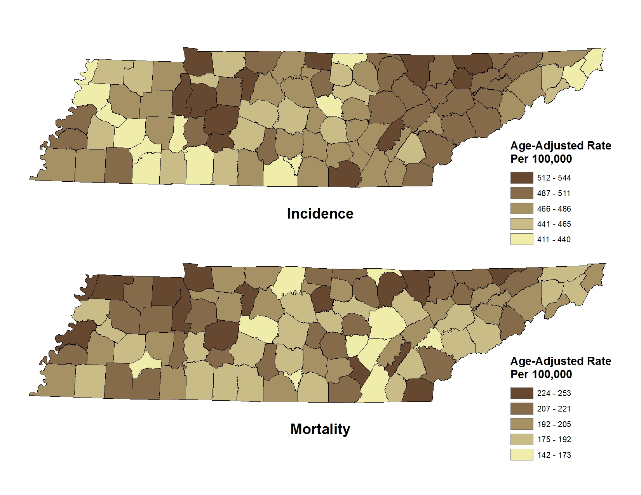

### 3. Age-adjusted Cancer Incidence and Mortality Rates by Resident County, Lung and Bronchus, Tennessee, 2008-2012

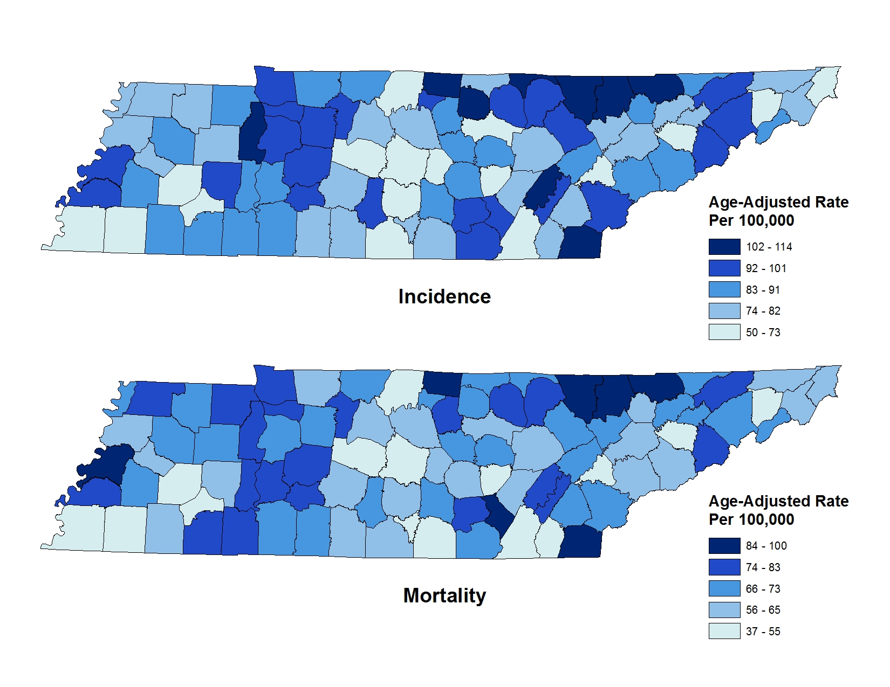

### 4. Age-adjusted Cancer Incidence and Mortality Rates by Resident County, Prostate, Tennessee, 2008-2012

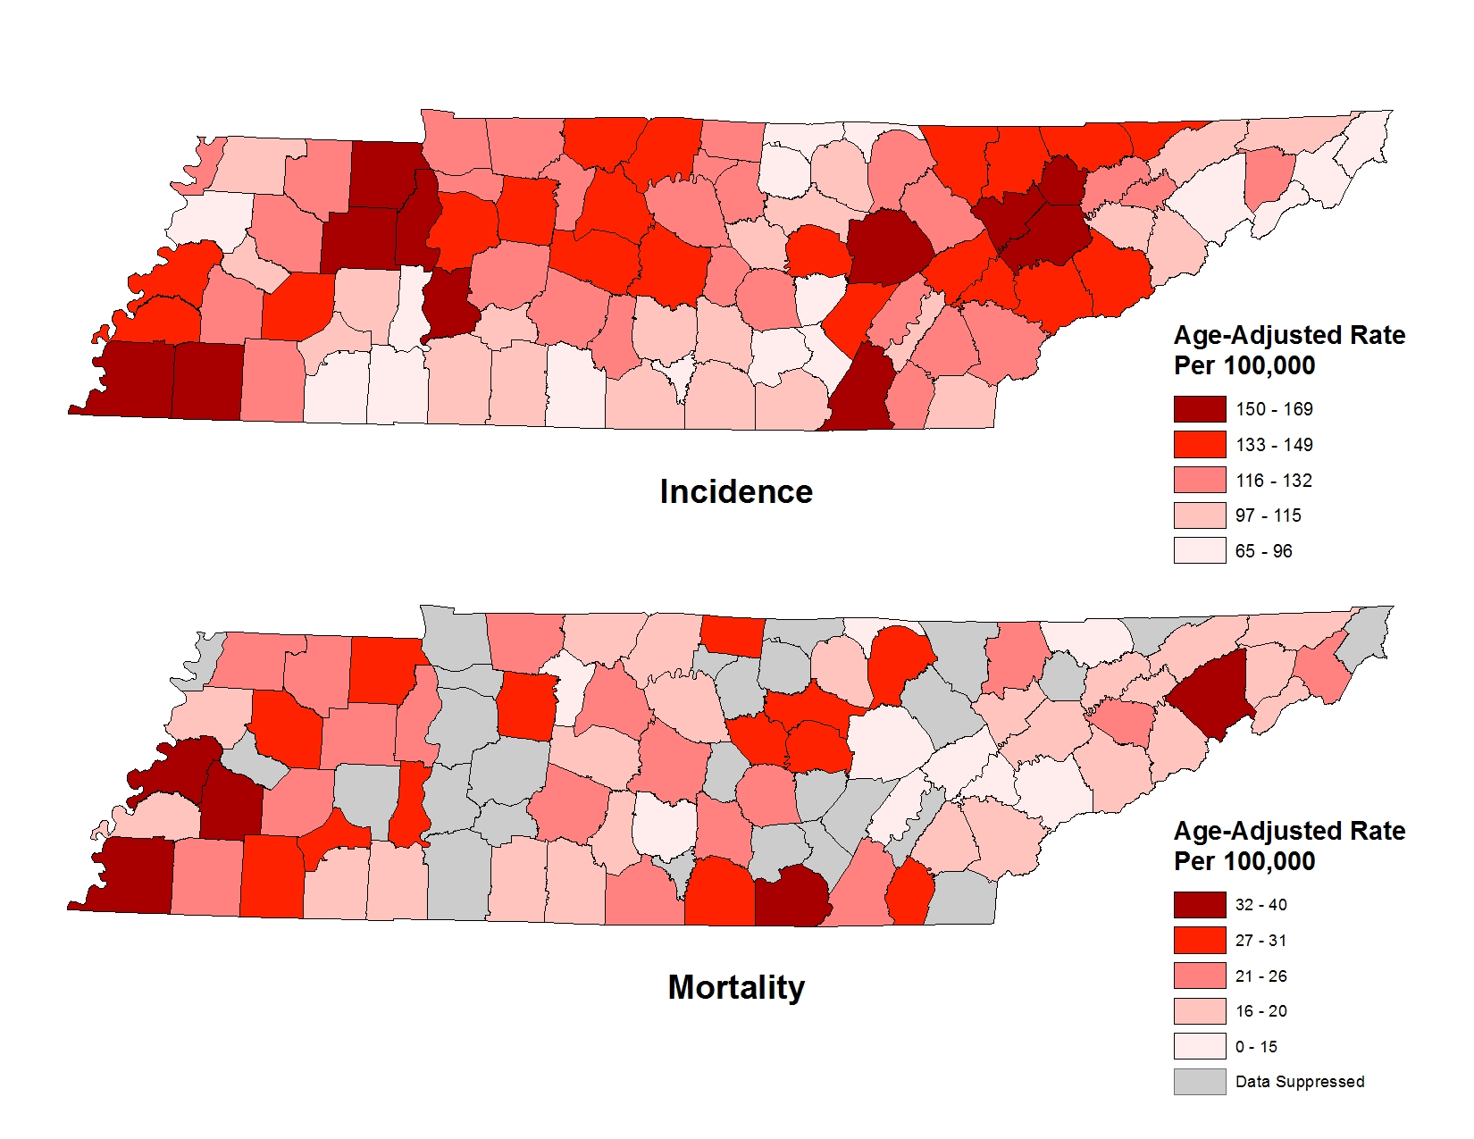

### 5. Age-adjusted Cancer Incidence and Mortality Rates by Resident County, Female Breast, Tennessee, 2008-2012

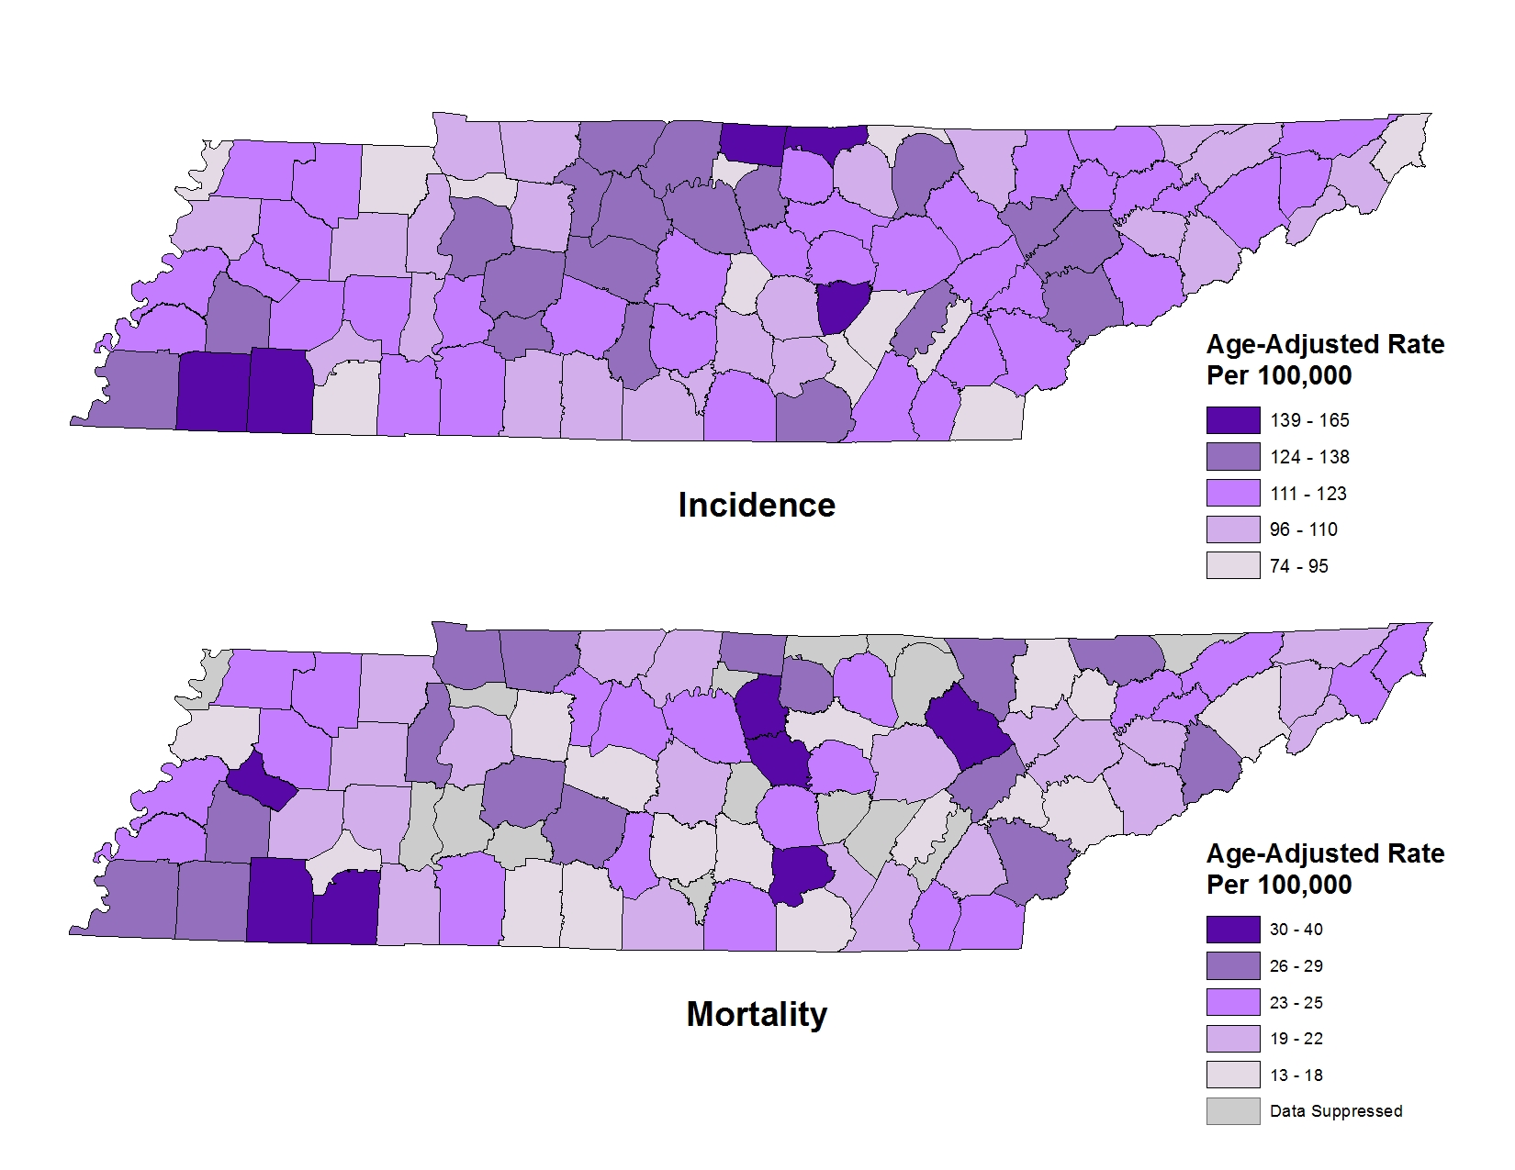

### 6. Age-adjusted Cancer Incidence and Mortality Rates by Resident County, Colon and Rectum, Tennessee, 2008-2012

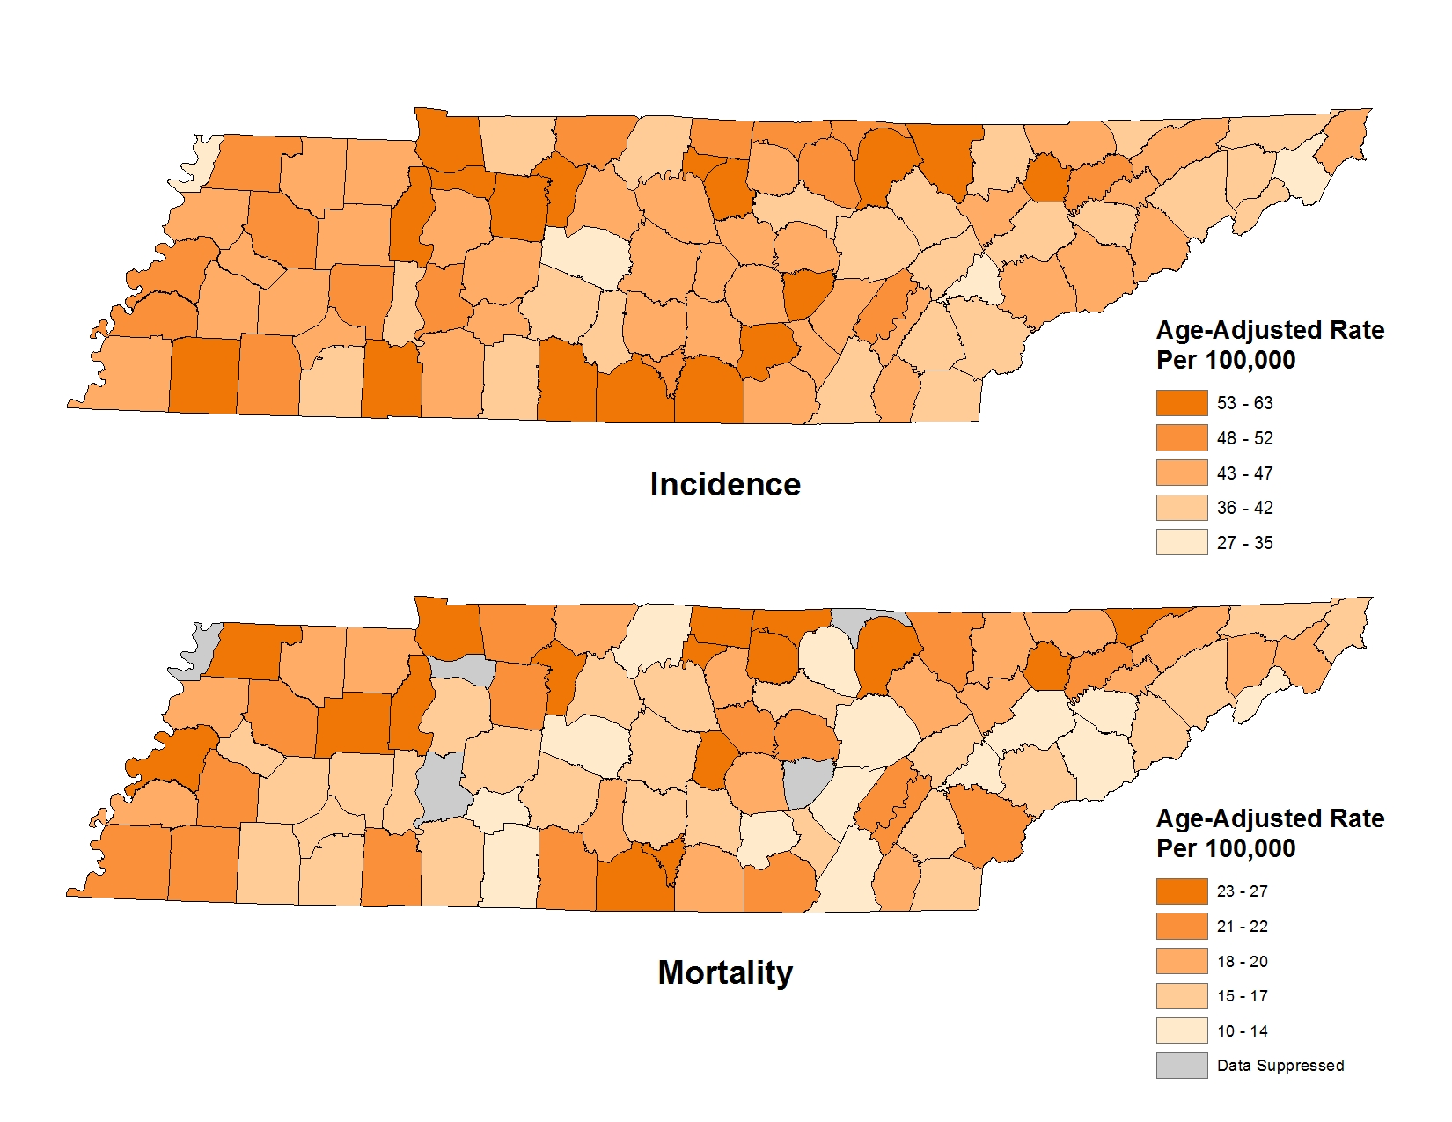

### 7. Age-adjusted Cancer Incidence and Mortality Rates by Resident County, Melanoma of the Skin, Tennessee, 2008-2012

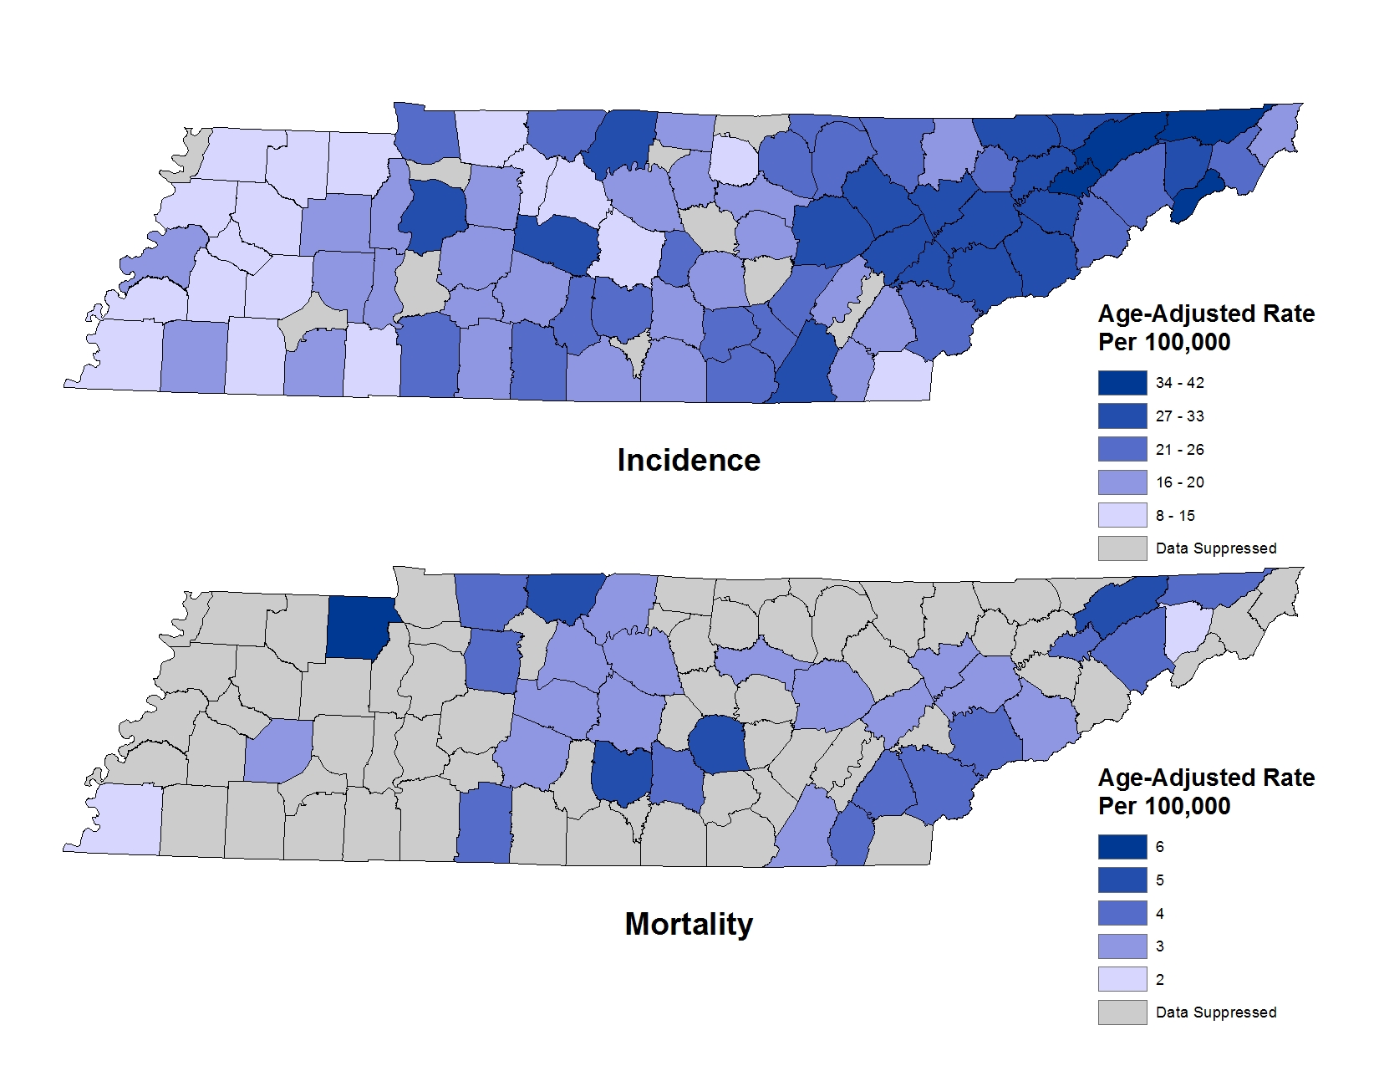

### 8. Age-adjusted Cancer Incidence and Mortality Rates by Resident County, Pancreas, Tennessee, 2008-2012

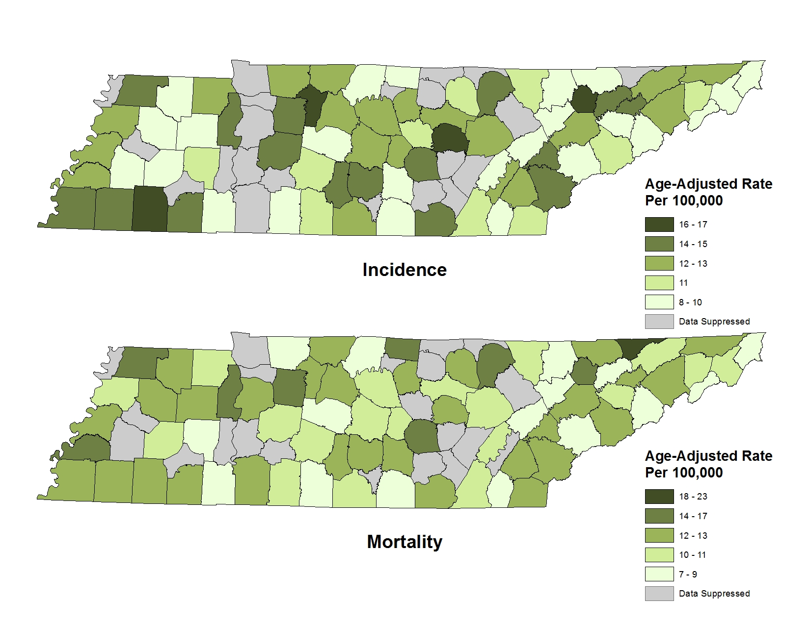

**Tables**

# Tables

## Table 1. Number of Deaths and Years of Potential Life Lost, By Gender and Race, Tennessee, 2008-2012

|  |  |  |  |  |  |  |  |  |  |
| --- | --- | --- | --- | --- | --- | --- | --- | --- | --- |
| **Number of Deaths & Years of Potential Life Lost to Cancer, by Gender and Race** | | | | | | | | | |
| **Year** | **Total** | **Female** | **Male** | **Black** | **White** | **Black**  **Female** | **Black**  **Male** | **White**  **Female** | **White**  **Male** |
| **2008** | 13,108 | 5,958 | 7,150 | 1,792 | 11,252 | 869 | 923 | 5,051 | 6,201 |
| **2009** | 13,407 | 6,108 | 7,299 | 1,905 | 11,438 | 885 | 1,020 | 5,188 | 6,250 |
| **2010** | 13,514 | 6,096 | 7,418 | 1,892 | 11,545 | 908 | 984 | 5,146 | 6,399 |
| **2011** | 13,461 | 6,161 | 7,300 | 1,950 | 11,430 | 920 | 1,030 | 5,197 | 6,233 |
| **2012** | 13,630 | 6,218 | 7,412 | 1,934 | 11,550 | 883 | 1,051 | 5,264 | 6,286 |
| **2008-2012** | 67,120 | 30,541 | 36,579 | 9,473 | 57,215 | 4,465 | 5,008 | 25,846 | 31,369 |
| **YPLL** | 562,818 | 254,652 | 308,139 | 100,524 | 457,100 | 47,130 | 53,379 | 204,584 | 252,504 |
| **AYLL** | 8.4 | 8.3 | 8.4 | 10.6 | 8.0 | 10.6 | 10.7 | 7.9 | 8.0 |

Data Source

## Table 2. Number of Deaths and Years of Potential Life Lost, by Common Cancer Site, Tennessee, 2008-2012

|  |  |  |  |  |  |  |  |  |
| --- | --- | --- | --- | --- | --- | --- | --- | --- |
| **Number of Deaths & Years of Potential Life Lost to Cancer, by Most Common Sites** | | | | | | | | |
| **Year** | **Breast** | **Colorectal** | **Leukemia** | **Liver & Intrahepatic**  **Bile Duct** | **Lung** | **Non-Hodgkin’s Lymphoma** | **Pancreas** | **Prostate** |
| **2008** | 847 | 1,225 | 491 | 362 | 4,281 | 434 | 759 | 571 |
| **2009** | 882 | 1,189 | 460 | 440 | 4,364 | 479 | 750 | 581 |
| **2010** | 870 | 1,201 | 529 | 403 | 4,400 | 458 | 779 | 600 |
| **2011** | 862 | 1,242 | 502 | 480 | 4,289 | 431 | 783 | 574 |
| **2012** | 905 | 1,181 | 541 | 528 | 4,327 | 430 | 786 | 545 |
| **2008-2012** | 4,366 | 6,038 | 2,523 | 2,213 | 21,661 | 2,232 | 3,857 | 2,871 |
| **YPLL** | 47,070 | 45,360 | 21,413 | 23,462 | 168,545 | 14,707 | 29,414 | 8,933 |
| **APYLL** | 10.8 | 7.5 | 8.5 | 10.6 | 7.8 | 6.6 | 7.6 | 3.1 |

Data Source

## Table 3. Number of Deaths and Years of Potential Life Lost, by Other Common Cancer Site, Tennessee, 2008-2012

|  |  |  |  |  |  |  |  |  |
| --- | --- | --- | --- | --- | --- | --- | --- | --- |
| **Number of Deaths & Years of Potential Life Lost to Cancer, by Other Common Sites** | | | | | | | | |
| **Year** | **Brain & Other CNS** | **Corpus and Uterus** | **Esophagus** | **Kidney & Renal Pelvis** | **Ovary** | **Stomach** | **Endocrine System including Thyroid** | **Urinary Bladder** |
| **2008** | 316 | 145 | 298 | 283 | 279 | 234 | 61 | 278 |
| **2009** | 370 | 136 | 302 | 289 | 279 | 239 | 52 | 273 |
| **2010** | 314 | 130 | 285 | 286 | 304 | 214 | 63 | 288 |
| **2011** | 320 | 159 | 313 | 314 | 321 | 211 | 46 | 267 |
| **2012** | 331 | 166 | 307 | 289 | 316 | 247 | 49 | 306 |
| **2008-2012** | 1,651 | 736 | 1,505 | 1,461 | 1,499 | 1,145 | 271 | 1,412 |
| **YPLL** | 24,079 | 6,057 | 14,927 | 12,370 | 12,627 | 9,763 | 3,948 | 6,541 |
| **APYLL** | 14.6 | 8.2 | 9.9 | 8.5 | 8.4 | 8.5 | 14.6 | 4.6 |

Data Source

# Technical Notes

## Statistical Methods

SAS 9.3 was used to prepare the incidence and mortality data and SEER*Stat 8.1.5 was used for counting numbers of new cases and deaths due to cancer and calculating age-adjusted rates and confidence intervals.

Confidence intervals were used to test if the difference in incidence or mortality rates between two groups or two years, e.g. blacks vs. whites or 2008 vs. 2012, was statistically significant. If the 95% confidence intervals did not overlap, the difference was determined to be statistically significant. Therefore, this is a conservative test of significance and there is a greater probability of finding non-significant differences than traditional tests of significance.

Pearson’s chi-squared test was used to test the differences in cancer stages, i.e. late stages (regional and distant combined) versus early stages (in situ and localized combined) between blacks and whites.

When interpreting cancer incidence and mortality data it is important to keep in mind multiple factors can impact cancer rates. Consumers of this data must use caution when interpreting the data in this report and consider that the data published in this report is dynamic. It is possible even after the standard reporting delay, some new cases may be reported, which could influence cancer rates. Caution should also be used when interpreting rates based on only a small number of cases. In order to protect patient confidentiality and ensure the integrity of the data, data based on counts smaller than 10 have been suppressed. Additionally, the confidence intervals associated with some cancers are very large, and caution should be used when interpreting the data.

## Software Used for Calculation

**Age-Adjusted Rates and Confidence Intervals:**

Surveillance Research Program, National Cancer Institute (2013). SEER*Stat (version 8.1.5) [Computer Software]. Calverton, MD. (<http://seer.cancer.gov/seerstat>)

**Probability of Developing or Dying of Cancer:**

DevCan: Probability of Developing or Dying of Cancer Software, Version 6.7.2. Statistical Research and Applications Branch, National Cancer Institute, 2014. (<http://surveillance.cancer.gov./devcan>)

**Years of Potential Life Lost Calculation:**

SAS Institute Inc. (2011). Base SAS® 9.3. Cary, NC: SAS Institute Inc.

## Explanation of Terms

***Age-adjusted Rate***

An age-adjusted incidence or mortality rate is a weighted average of the age-specific incidence or mortality rates, where the weights are the counts of persons in the corresponding age groups of a standard million population. Aging is an important risk factor for the development of cancer. Hence, if one population has a significantly greater proportion of older people than another population, one would expect a larger number of cancers in the older population. Therefore, rates need to be age-adjusted to remove the confounding effect of age before comparisons are made between populations with different age distributions. In this report, incidence and mortality rates are age-adjusted to the 2000 United States Standard Population with 19 age groups.

***Average years of potential life lost***

Average years of life lost is simply an average derived by dividing Years of Potential Life Lost (YPLL) by the actual number of deaths for each cancer site, over the defined time period. This parameter is interesting because it provides a measure of the burden of cancer to the individual patient, rather than the population as a whole. Effectively it shows, on average, how much a patient’s life is likely to be shortened by their cancer.

$$Average Years of Potential Life Lost=\frac{Years of Potential Life Lost during period}{Actual Number of Deaths during period}$$

***Cancer Coding***

The Tennessee Cancer Registry uses the International Classification of Diseases for Oncology, 3rd Edition (ICD-O-3) to code site (topography), histology (morphology), and behavior (e.g. whether malignant or not) of incident cases. Cases are categorized according to the 2003 revised recodes of the Surveillance, Epidemiology and End Results (SEER) program of the National Cancer Institute (NCI). These recodes define standard groupings of primary cancer sites. Following CDC’s National Program of Cancer Registries (NPCR) and SEER cancer registries’ guidelines, the TCR considers as reportable all incident cases with a behavior code of 2 (in situ, noninvasive) or 3 (invasive, primary site only) in ICD–O–3 terminology with the exception of in situ cancer of the cervix. Benign brain tumors are also reportable but not included in this report. When reporting childhood cancers, the International Classification of Childhood Cancer, 3rd Edition (ICCC-3) is used. For cancer mortality data, the International Classification of Diseases, 10th Revision (ICD-10), is used.

***Cancer Staging***

Stage provides a measure of disease progression, detailing the degree to which the cancer has advanced. The SEER summary stage method is used in this report, which describes cancers in five stages:

1. *In situ*\*: Abnormal cells are present only in the layer of cells in which they originated.
2. *Localized*: Cancer is limited to the organ in which it began, without evidence of spread.
3. *Regional*: Cancer has spread beyond the primary site to nearby lymph nodes or organs and tissues.
4. *Distant*: Cancer has spread from the primary site to distant organs or distant lymph nodes.
5. *Unknown*: There is not enough information to determine the stage.

*Although in situ cancers are included in analyses of stage at diagnosis, these cancers (with the exception of in situ bladder cancer) are not included in incidence counts and rates.

***Confidence Interval***

A confidence interval is a range of values that has a specified probability of containing the true rate of interest in the population. The width of a confidence interval reflects the amount of variability in the estimated rate. In this report, 95% confidence intervals were calculated using a gamma distribution method developed by Fay and Feuer and modified by Tiwari, Clegg, and Zou.

***Incidence***

Incidence is defined as the number of new cancers diagnosed in the population at risk in the reference year. The population considered at risk for cancer in this report is the entire resident population of Tennessee in the reference year.

***Incidence Rate***

The cancer incidence rate is the number of new cases of cancer diagnosed in a specified population during a specified time period, usually expressed as the number of new cases per 100,000 persons at risk. That is,

$$Incidence Rate=(\frac{Number of New Cases}{Population at Risk})*100,000$$

The numerator of the incidence rate is the number of newly diagnosed cancer cases; the denominator of the incidence rate is the size of the population at risk. The number of new cancers may include multiple primary cancers occurring in one patient. The primary site reported is the site of origin and not the metastatic site, the distant site to which the cancer has spread. In general, the incidence rate does not include recurrences. The incidence rate can be computed for a given type of cancer or for all cancers combined. Incidence rates presented in this report are for invasive cancers and both invasive and in situ bladder cancer only, unless otherwise specified. When cancer stage was considered, cases diagnosed at any stage, including the in situ stage, were included in the analyses.

***Median***

The median is the middle value of an ordered set of numbers: half the values are greater than the median and half are less than the median. The median is less sensitive than the mean to extreme values, and is a better measure of central tendency for data with skewed distributions.

***Mortality***

Mortality is defined as the number of deaths from cancer in the population at risk in for the reference year. A cancer death is defined as a death for which cancer is determined to be the underlying cause of death based on the death certificate.

***Mortality Rate***

The cancer mortality rate is the number of deaths with cancer as the underlying cause of death in a specified at-risk population in a given time period, usually expressed as the number of deaths due to cancer per 100,000 persons at risk. That is,

$$Mortality Rate=\left(\frac{Number of Cancer Deaths}{Population at Risk}\right)*100,000$$

***Mortality-to-Incidence Ratio (M:I Ratio)***

In this report, mortality-to-incidence ratio was calculated as the ratio of age-adjusted mortality and incidence rates. In a general sense, the higher the ratio, the higher fatality for the cancer or the lower the survival. However, for some cancers with very high fatality, e.g. pancreatic cancer, the M:I ratio may exceed 1 because the incidence and mortality cohorts are not exactly the same. In addition, the age-adjustment process may also make this possible because the age of a patient at death is likely greater than that at diagnosis; therefore, the patient may be accounted for at one age group for incidence and at an older age group for mortality.

$$M:I Ratio= \frac{Mortality Rate}{Incidence Rate}$$

***Prevalence***

Current cigarette use and cancer screening prevalence data from the Tennessee BRFSS are presented in this report (See Cancer Screening Prevalence in Tennessee & Cigarette Smoking Prevalence in Tennessee). Prevalence is defined as the percentage of people exhibiting the behavior out of the total number in the defined population.

***Race and Ethnicity***

Cancer incidence and mortality can vary greatly by race and ethnicity. According to the 2010 U.S. census (United States Census Bureau, 2010), non-Hispanic Whites account for 78.4 of Tennessee’s population, and non-Hispanic Blacks represent 16.7% of Tennessee’s population. Given Tennessee’s small minority population, displaying detailed information by racial/ethnic group leads to some cell counts that are too small to display publically and rates may be unstable.

***Resident County***

The resident county is the geographical variable that illustrates the county of residence at diagnosis.

***Suppression of Rates and Counts***

Due to concerns regarding statistical reliability, statistics were suppressed when there were 1-9 reported cases. Counts or rates that were suppressed in this report are denoted by “^”.

***Tennessee counties and regions***

In this report, Tennessee’s 95 counties are grouped into eight regions. Metropolitan counties are grouped into the regions where they are located.

***Trends***

Trend data should be interpreted with caution. Increases and decreases in rates over time may reflect changes in diagnostic methods or case reporting rather than genuine changes in cancer occurrence.

***Years of potential life lost***

Years of potential life lost (YPLL) is another indicator often used to describe disease burden. It is an estimate of the years a person would have lived if he or she had not died prematurely. YPLL highlights the loss to society as a result of deaths in childhood, adolescence and early adulthood and is calculated as the number of years of potential life lost by each death occurring before a predetermined end point, set at age 75 years in this report.

$$Years of Potential Life Lost=Predetermined End Point Age-Age of Decedent Who Died Prior to End Point Age$$

## Data Sources

**Tennessee Cancer Registry (TCR) Incidence Data:**

The cancer incidence data contain records of primary cancer cases first diagnosed among Tennessee residents between January 1, 2008 and December 31, 2012, and were reported to the TCR as of May 2015. Cases with gender reported as hermaphrodite or transsexual were not included in this report. Cases with race other than white or black (1,286 cases) and unknown race (1,396 cases) were included in the “Total Population” category. Two (2) cases with unknown age of diagnosis were excluded from all analyses except the calculation of the leading causes of cancer incidence and cancer by stage. A total of 138 newly diagnosed cases did not have information on county and region of diagnosis. These cases were included in the state level statistics but excluded from county level statistics.

**Cancer Mortality Data:**

The cancer mortality data contain records of all mortalities among Tennessee residents. The record-level mortality data were from the Death Statistical System provided by the Office of Health Statistics, Tennessee Department of Health. There were 27 mortality cases missing gender information and 112 cases did not contain race data. These cases were excluded from all analyses except the calculation of the leading causes of cancer mortality. 2,282 deaths were of race other than white or black and were included in the “Total Population” category.

**Behavioral Risk Factor Surveillance System (BRFSS) Data:**

BRFSS is a CDC-funded, state-administered, random-digit-dialed telephone survey of the U.S. non-institutionalized population, 18 years of age and older that collects information on health risk behaviors, preventive health practices, and health care access primarily related to chronic disease and injury. BRFSS was established in 1984 by the Centers for Disease Control and Prevention (CDC); currently data are collected monthly in all 50 states, the District of Columbia, Puerto Rico, the U.S. Virgin Islands, and Guam. Nationwide BRFSS data were the median for 50 states and Washington D.C.

**State Cancer Profiles:**

State Cancer Profiles is a web-based, comprehensive, and interactive data query system provided by the National Cancer Institute (NCI) and the Centers for Disease Control & Prevention (CDC). Tennessee and United States cancer mortality trend data and Tennessee cancer rankings in incidence and mortality were based on age-adjusted rates of 50 states and Washington D.C. obtained online from the following website: <http://statecancerprofiles.cancer.gov>.

# References

Adamo M, Dickie, L, Ruhl J. (2015, January). SEER Program Coding and Staging Manual 2015. National Cancer Institute, Bethesda, MD 20850-9765. Retrieved from <http://seer.cancer.gov/tools/codingmanuals/>

American Cancer Society. (2014). Lifetime Risk of Developing or Dying From Cancer.

Retrieved March 20, 2015, from <http://www.cancer.org/cancer/cancerbasics/lifetime-probability-of-developing-or-dying-from-cancer>

American Cancer Society. (2015). What are the Differences Between Cancers in

Adults and Children? Retrieved April 30, 2015, from <http://www.cancer.org/cancer/cancerinchildren/detailedguide/cancer-in-children-differences-adults-children>

Beaulieu, N., Bloom, D. E., Reddy Bloom, L., & Stein, R. M. (2009). Breakaway: The global burden of cancer: challenges and opportunities. A report from the Economist Intelligence Unit. Economist Intelligence Unit.

Burnet, N. G., Jefferies, S. J., Benson, R. J., Hunt, D. P., & Treasure, F. P. (2005). Years of life lost (YLL) from cancer is an important measure of population burden – and should be considered when allocating research funds. *British Journal of Cancer*, *92*(2), 241–245.

Centers for Disease Control (CDC). (1986). Premature Mortality in the United States: public health

issues in the use of years of potential life lost. *Morbidity and Mortality Weekly Report*

*(MMWR)*, 1S-11S.

Centers for Disease Control (CDC). (2015). State Cancer Profiles. Retrieved from

<http://statecancerprofiles.cancer.gov/>

Centers for Disease Control (CDC). (2015). Behavioral Risk Factor Surveillance System: Prevalence and Trends Data. Retrieved from <http://apps.nccd.cdc.gov/brfss/page.asp?yr=2012&state=TN&cat>=

Fay, M.P., Pfeiffer, R., Cronin, K.A., Le, C. and Feuer, E.J. (2003) "Age-conditional probabilities of developing cancer" Statistics in Medicine, 22(11): 1837-1848.

Fay, M. P., & Feuer, E. J. (1997). Confidence Intervals for Directly Standardized Rates: A Method

Based on the Gamma Distribution. *Statistics in Medicine*, *16*, 791-801. Retrieved from

<http://citeseerx.ist.psu.edu/viewdoc/download?doi=10.1.1.502.2815&rep=rep1&type=pdf>

Fay M.P. (2004). "Estimating age conditional probability of developing disease from surveillance data". Population Health Metrics 2:6. Retrieved from <http://www.pophealthmetrics.com/content/2/1/6>

Lifetime Risk (Percent) of Being Diagnosed with Cancer by Site and Race/Ethnicity: Males, 18 SEER Areas, 2009-2011 (Table 1.16) and Females, 18 SEER Areas, 2009-2011 (Table 1.17). 2014. Retrieved from <http://seer.cancer.gov/csr/1975_2011/results_merged/topic_lifetime_risk_diagnosis.pdf>

Lifetime Risk (Percent) of Dying from Cancer by Site and Race/Ethnicity: Males, Total US, 2009-2011 (Table 1.19) and Females, Total US, 2009-2011 (Table 1.20). 2014. Retrieved from <http://seer.cancer.gov/csr/1975_2011/results_merged/topic_lifetime_risk_death.pdf>

Mariotto, A. B., Yabroff, K. R., Shao, Y., Feuer, E. J., & Brown, M. L. (2011). Projections of the

Cost of Cancer Care in the United States 2010-2020. Journal of the National Cancer Institute,

103(2), 117-128.

National Cancer Institute (NCI). (2013). Cancer Prevalence and Cost of Care Projections. Retrieved from <http://costprojections.cancer.gov>

National Cancer Institute. (2015, July). State Cancer Profiles. Retrieved from

<http://statecancerprofiles.cancer.gov/index.html>

National Cancer Institute (NCI). (2015). Surveillance, Epidemiology, and End Results. Retrieved from <http://seer.cancer.gov/index.html>

National Lung Screening Trial Research Team (NLSTRT). (2011). The National Lung Screening Trial: overview and study design. Radiology, 258(1), 243-253.

Preacher, K. J. (2001, April). Calculation for the chi-square test: An interactive calculation tool for chi-square tests of goodness of fit and independence [Computer software]. Retrieved from [http://quantpsy.org](http://quantpsy.org/).

Surveillance, Epidemiology, and End Results (SEER) Program ([www.seer.cancer.gov](http://www.seer.cancer.gov)) SEER*Stat Database: Incidence - SEER 18 Regs Research Data + Hurricane Katrina Impacted Louisiana Cases, Nov 2013 Sub (1973-2010 varying) - Linked To County Attributes - Total U.S., 1969-2012 Counties, National Cancer Institute, DCCPS, Surveillance Research Program, Surveillance Systems Branch, released April 2015, based on the November 2014 submission.

Surveillance, Epidemiology, and End Results (SEER) Program ([www.seer.cancer.gov](http://www.seer.cancer.gov)) SEER*Stat Database: Mortality - All COD, Aggregated With State, Total U.S. (1969-2012) <Katrina/Rita Population Adjustment>, National Cancer Institute, DCCPS, Surveillance Research Program, Surveillance Systems Branch, released April 2015. Underlying mortality data provided by NCHS ([www.cdc.gov/nchs](http://www.cdc.gov/nchs)).

Tiwari, R. C., Clegg, L. X., & Zou, Z. (2006). Efficient interval estimation for age-adjusted cancer

rates. *Statistical Methods in Medical Research*, 15, 547-569

TN Department of Health Office of Health Statistics. (2012). Behavioral Risk Factor Surveillance

System (BRFSS). Retrieved March 17, 2015, from Tennessee Department of Health website: <http://tn.gov/health/topic/statistics-brfss>

United States Census Bureau. (2012). American FactFinder. (K. Herget, Ed.) United States Census Bureau. Retrieved from <http://factfinder2.census.gov>

U.S. Department of Health and Human Services. (2013). *NHLBI Fact Book, Fiscal Year 2012*. Retrieved

from <http://www.nhlbi.nih.gov/files/docs/factbook/FactBook2012.pdf>

Young JL Jr, Roffers SD, Ries LAG, Fritz AG, Hurlbut AA (2001). *SEER Summary Staging*

*Manual - 2000: Codes and Coding Instructions*, National Cancer Institute, NIH Pub. No. 01-4969.