The Tennessee Open Meetings Act passed by the General Assembly in 1974 requires that meetings of state, city and county government bodies be open to the public and that any such governmental body give adequate public notice of such meeting.

TENNESSEE DEPARTMENT OF HEALTH
MEMORANDUM

Date: September 7, 2016

To: Shelley Walker, Director of Communications and Media Relations
Amber Ricks, Commissioner Office
Michelle Long, Assistant Commissioner,
Bureau of Health Licensure and Regulation

From: Donna G. Tidwell, Director of Emergency Medical Service

Name of Board or Committee: Education Committee

Date of Meeting: September 27th, 2016

Time: 1:00 p.m. Central Standard Time

Place: Iris Room, First Floor
665 Mainstream Drive
Nashville, TN 37243

Major Item(s) on Agenda: See Attached Agenda

This memo shall be forwarded from individual programs to the Public Information Office on the 15th day of the preceding month. The Public Information Office will prepare the monthly list of meetings within the Department and have ready for distribution to state media by the 28th day of the preceding month.

PH-1850 (Rev. 3/79) RDA N/A

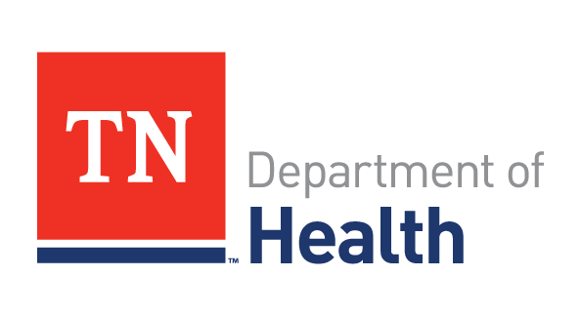

JOHN J. DREYZEHNER, MD, MPH BILL HASLAM COMMISSIONER GOVERNOR

The mission of the Tennessee Department of Health is to protect, promote and improve the health and prosperity of people in Tennessee

AGENDA:

1:00 P.M.

- Roll Call

- Approval of Minutes

- NREMT reports

- Sub Committee Report

- Old Business

- New Business

Emergency Medical Services
Education Committee
September 27th, 2016
PLEASE REMEMBER TO SILENCE YOUR ELECTRONIC DEVICES WHEN
THE BOARD IS IN SESSION

