DIAGNOSTIC SERVICES

**HEALTH SCIENCE**

**ABOUT THE PROGRAM OF STUDY**

*Diagnostic Services*is designed to prepare students to pursue careers in the fields of radiology, medical laboratory, optometry, and other patient diagnostic procedures. Upon completion of this course, proficient students will be able to describe new and evolving diagnostic technologies, compare and contrast the features of healthcare systems, explain the legal and ethical ramifications of the healthcare setting, and begin to perform foundational healthcare skills. In addition, students will have the option to complete a clinical internship.

**Industry Certifications options include:**

• Certified EKG Technician

*Level Four*

*Level Three*

*Level Two*

*Level One*

This is not an exhaustive list of all of the opportunities available in Tennessee.

**CAREER OPPORTUNITIES**

According to the Bureau of Labor Statistics, employment in *diagnostic services* careers is projected to grow faster or much faster than average through 2024. An increase in the aging population is expected to lead to a greater need to diagnose medical conditions through laboratory procedures, medical imaging, and electrocardiography. All careers in diagnostic medicine are considered to have a bright outlook in Tennessee.

**2024 Projected Employment for Medical Diagnostics Related Occupations**

|  |  |  |
| --- | --- | --- |
| Occupations | Total Percent Change | Total Annual Av. Openings |
| Phlebotomists | 36.2% | 160 |
| Medical & Clinical Lab Technologists | 17.4% | 200 |
| Radiologic Technologists | 24.7% | 220 |



**For more information, contact:**

**School High School**

**County Name Schools**

**CTE Director: Name**

**Email**

**Instructor: Name**

**Email**

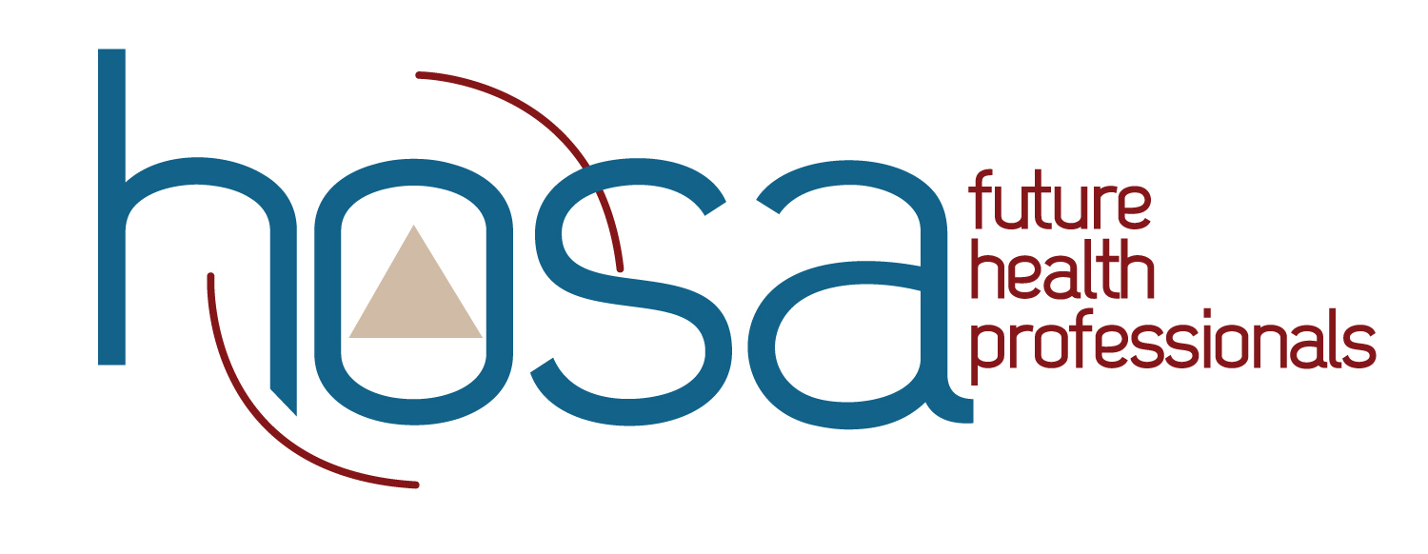

Students in this program of study will be eligible to join HOSA: Future Health Professionals. In addition to school events, students will be able to compete at the regional, state, and national level.

HOSA's two-fold mission is to promote career opportunities in the health care industry and to enhance the delivery of quality health care to all people. HOSA's goal is to encourage all health occupations instructors and students to join and be actively involved in the HSE-HOSA Partnership. HOSA provides a unique program of leadership development, motivation, and recognition exclusively for secondary, postsecondary, adult, and collegiate students enrolled in HSE programs. HOSA is 100% health care! For more information, please visit <http://www.hosa.org> .



**POSTSECONDARY OPTIONS**

Have you registered for the Tennessee Promise? Seniors enrolled in this program have the chance to attend a two year program at a Tennessee College of Applied Technology (TCAT), community college, or some two year university programs for free! To learn more, please see your school counselor or visit <http://www.tennesseepromise.gov>.

|  |  |
| --- | --- |
| Postsecondary Offerings Aligned to this Program of Study | |
| School | **Degree Program** |
| Chattanooga & Volunteer State Community Colleges | A.A.S. Cardiovascular Technology |
| ETSU, UTK, MTSU, APSU | B.S. Radiologic Technologist & Medical Lab Technology |
| For more college and career planning resources, visit http://collegefortn.org. | |

**Annual Average Openings for Cardiovascular Technologists in Tennessee (2014-2024)**



