STRUCTURAL SYSTEMS
__________

Level One
Level Two
Level Three
Architecture & Construction
__________

Level Four

ABOUT THE PROGRAM OF STUDY
Industry certification options include:
- NCCER Core Curriculum
- NCCER Carpentry Level One
- NCCER Carpentry Level Two

The Structural Systems program of study prepares students with the knowledge and skills related to residential and commercial carpentry. Course content covers wood, metal, and concrete building materials, fasteners, hand and power tools, fabrication based on construction plans, framing of platform and post-and-beam structures, stairs, structural loads, installation and trim of windows and doors, installation and repair of gypsum wallboard, exterior finish work, cabinet installation, and thermal and moisture protection. The fourth level course, Construction Practicum, places students with industry partners to complete a capstone construction project. Upon completion of the program of study, students will be equipped for workforce entry, apprenticeships, or to continue training at the postsecondary level.
Career Opportunities

Occupation | Total Percent Change | Annual Avg. Openings
Maintenance & Repair Workers, General | 7.7% | 880
Construction Laborers | 12.9% | 840
Construction Managers | 4.6% | 235
Civil Engineers | 17.6% | 215
Supervisors of Construction & Extraction Workers | 9.2% | 210
Carpenters | 5.0% | 200
Operating Engineers & Other Construction Equipment Operators | 14.3% | 185
Cost Estimators | 11.9% | 170
Sheet Metal Workers | 14.4% | 160
Roofers | 19.0% | 115
Cement Masons & Concrete Finishers | 23.1% | 90
Painters, Construction & Maintenance | 4.5% | 90
Brickmasons & Blockmasons | 38.9% | 60
Construction & Building Inspectors | 9.8% | 55

Structural Systems Related Occupations with the Most Annual Average Openings in Tennessee (2014-2022)
CAREER OPPORTUNITIES
Employment for carpenters is projected to grow by 5 percent in Tennessee between 2014 and 2022 with a total annual average of 200 openings. Skills students develop in the program of study are transferrable to additional growing occupations related to structural systems listed in the chart to the right. Opportunities are available in a range of occupations including supervisory roles such as construction manager or first-line supervisor. Job outlook is positive in all regions of the state; however, more opportunities are available in urban and surrounding areas.

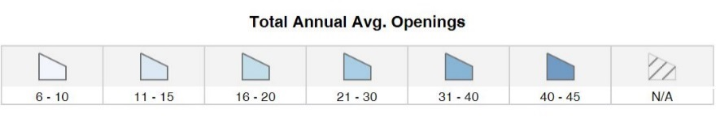
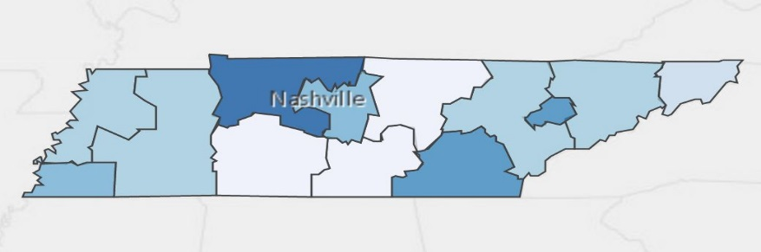
Annual Average Openings for Carpenters in Tennessee (2014-2022)
Source: TN Department of Labor and Workforce Development. (2015). Employment Security Division, Labor Market Information Section, on the internet at https://www.jobs4tn.gov/ (visited Feb. 10, 2016)

Students in this program of study will be eligible to join SkillsUSA. In addition to school events, students will be able to compete at the regional, state, and national level. Through SkillsUSA, students not only learn about construction, but also professionalism, leadership, and workplace skills. Walk away from your high school career with experience in competing, networking, applying course content, and more!
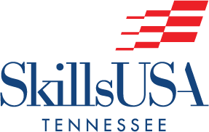
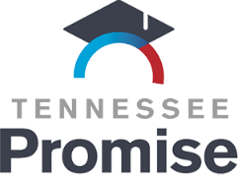
School | Degree Program
TCAT Nashville | Building Construction Technology
TCAT Crossville | Building Construction Technology
Cleveland State | Surveying
TCAT Paris | Residential Building Maintenance
Chattanooga State | Construction Management (concentration)
Chattanooga State | Construction Engineering Technology
For more college and career planning resources, visit http://collegefortn.org.

See your teacher to learn more about SkillsUSA or visit http://tnskillsusa.com/.
For more information, contact:
Central High School
County Name Schools
CTE Director: Susan Smith Susan.Smith@school.edu
Instructor: Bob Johnson Bob.Johnson@school.edu

POSTSECONDARY OPTIONS

community college, or some 2-year university programs for free! To learn more, please see your school counselor or visit http://www.tennesseepromise.gov.

Have you registered for the Tennessee Promise? Seniors enrolled in this program have the chance to attend a two-year program at a Tennessee College of Applied Technology (TCAT), community college, or some 2-year university programs for free! To learn more, please see your school counselor or visit http://www.tennesseepromise.gov.

