ARCHITECTURAL & ENGINEERING DESIGN
__________

Level One
Level Two
Level Three
Architecture & Construction
__________

Level Four

ABOUT THE PROGRAM OF STUDY
Dual credit/ dual enrollment options include:
- Course A
- Course B

The Architectural & Engineering Design program of study prepares students for a variety of engineering and design professions including architectural, civil, or mechanical design. Students will develop problem solving and critical thinking skills by identifying the relationship between available resources and requirements of a project/problem to accomplish realistic planning. Students create design solutions for increasingly sophisticated problem sets as they progress through the program of study, presenting information through various modes of visual communication such as drawing, rendering, and modeling in combination with verbal and written communication. In the third level course, students may focus in architectural or mechanical design. Students will have the opportunity to participate in the Engineering Practicum course which places students with industry partners to complete a design project, report the results, and present their project before an audience.
Career Opportunities

Occupation | Total Percent Change | Annual Avg. Openings
Industrial Engineers | 7.5% | 280
Civil Engineers | 17.6% | 215
Mechanical Engineers | 5.3% | 170
Architectural and Engineering Managers | 9.2% | 90
Electrical Engineers | 7.5% | 80
Engineers, All Other | 10.1% | 60
Electrical and Electronic Engineering Technicians | 0.1% | 55
Architects, Except Landscape and Naval | 12.7% | 50
Electronics Engineers, Except Computer | 17.3% | 50
Industrial Engineering Technicians | 1.1% | 45
Environmental Engineers | 17.1% | 40
Surveying and Mapping Technicians | 12.4% | 40
Nuclear Engineers | 8.8% | 40
Mechanical Engineering Technicians | 7.5% | 35

Architecture & Engineering Occupations with the Most Annual Average Openings in Tennessee (2014-2022)
CAREER OPPORTUNITIES
The architecture and engineering occupation group is projected to grow by 8 percent in Tennessee between 2014 and 2022 with a total annual average of 1,475 openings. Industrial engineers, civil engineers, and mechanical engineers are projected to have the most annual average openings. Higher growth and higher pay is projected for occupations which require bachelor’s degrees or higher in this group. Job opportunities are strongest in urban and surrounding areas in Tennessee.

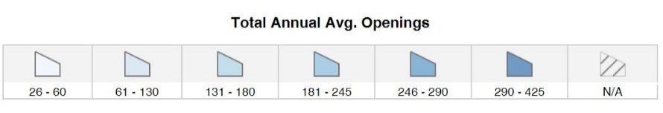
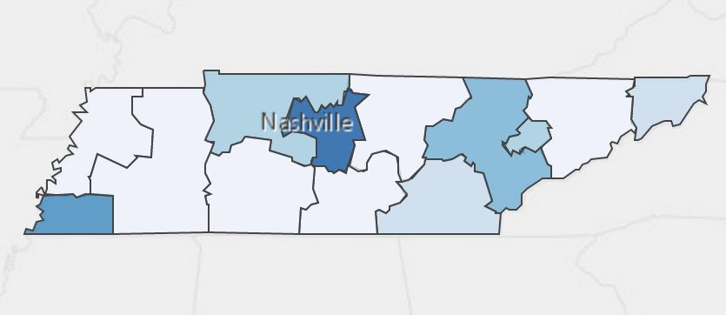
Annual Average Openings for Architecture & Engineering Occupations in Tennessee (2014-2022)
Source: TN Department of Labor and Workforce Development. (2015). Employment Security Division, Labor Market Information Section, on the internet at https://www.jobs4tn.gov/ (visited Feb. 9, 2016)

Students in this program of study will be eligible to join SkillsUSA. In addition to school events, students will be able to compete at the regional, state, and national level. Through SkillsUSA, students not only learn about design, but also professionalism, leadership, and workplace skills. Walk away from your high school career with experience in competing, networking, applying course content, and more!

School | Degree Program
TCAT Nashville | Drafting & CAD Technology
TCAT Hohenwald | Drafting & CAD Technology
Nashville State Community College | Electrical Engineering Technology
Cleveland State | Civil Technology
Chattanooga State | Engineering Technology, Civil Engineering, Electrical Engineering, or Mechanical Engineering
For more college and career planning resources, visit http://collegefortn.org.

See your teacher to learn more about SkillsUSA or visit http://tnskillsusa.com/.
For more information, contact:
Central High School
County Name Schools
CTE Director: Susan Smith Susan.Smith@school.edu
Instructor: Bob Johnson Bob.Johnson@school.edu

POSTSECONDARY OPTIONS

community college, or some 2-year university programs for free! To learn more, please see your school counselor or visit http://www.tennesseepromise.gov.

Have you registered for the Tennessee Promise? Seniors enrolled in this program have the chance to attend a two-year program at a Tennessee College of Applied Technology (TCAT), community college, or some 2-year university programs for free! To learn more, please see your school counselor or visit http://www.tennesseepromise.gov.

