Food Science
Education & Training
Agriculture, Food, and Natural Resources
__________

Level Three
Level One
Level Four
Level Two

Dual credit/dual enrollment options include:
- Course A
- Course B
¹ Satisfies one lab science credit required for graduation.

ABOUT THE PROGRAM OF STUDY
The Food Science program of study designed to introduce students to the growing fields of food science and technology industry. This program of study includes plant and animal structural anatomy, systems, economics of production, genetics and biotechnology, and other management approaches associated with plant and animal production. Advanced courses explore food safety and sanitation, foodborne pathogens, food-related standards and regulations, characteristics and properties of food products, processing and grading techniques and skills, and food labeling and packaging. Upon completion of this course, students will be equipped with the technical knowledge and skills necessary for further education and careers in food science.

The job outlook for this program of study is growing within the food science and technicians occupations.

Source: Tennessee Department of Labor and Workforce Development. Accessed Aug. 2017

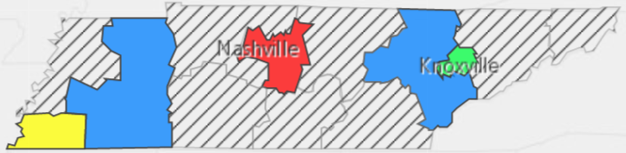

Food Science Related Occupations with Largest Annual Percentage of Openings in Tennessee (2014-2024)
Occupation | 2014 Estimated Employment | 2024 Projected Employment | Employment Change | Annual Avg. Percent Change
19-1013 Soil and Plant Scientists | 200 | 200 | 10 | 1%
19-4011 Food science technicians | 520 | 560 | 20 | 7%
25-1041 Agricultural Sciences Teachers, Postsecondary, Food Science and Processing | 260 | 290 | 10 | 14%
51-3021 Butchers and meat cutters | 2,750 | 3,100 | 350 | 13%
Source: TN Dept of Labor & Workforce Dev, Div Emp Sec, R&S
Downloaded: May 17, 2017

POSTSECONDARY OPTIONS
Have you registered for the Tennessee Promise? Seniors enrolled in this program have the chance to attend a two-year program at a Tennessee College of Applied Technology (TCAT), community college, or some two-year university programs for free! To learn more, please see your school counselor or visit http://www.tennesseepromise.gov.

Postsecondary Offerings
Program of Study | School | Degree Program
Food Science and Technology Options: Pre-Pharmacy, Pre-Professional, Science, Technology/Business  Animal Science/Plant Science | University of Tennessee, Knoxville | Bachelor’s, Master’s , and/or Doctoral
Animal Science/Plant Science | Austin Peay State University  Middle Tennessee State University  Tennessee State University  Tennessee Tech University  University of Tennessee, Martin | Bachelor’s
For more college and career planning resources, visit http://collegefortn.org.

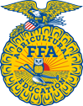
For more information, contact:
Name of High School
Name of School System
CTE Director: [enter name]
Email
Teacher: [enter name]
Email
Students in this program of study will be eligible to join FFA. In addition to school events, students will be able to compete at the district, regional, state, and national levels. Through FFA, students not only learn about agriculture, but also professionalism, leadership, and soft skills. Walk away from your hig5h school career with experience in competing, networking, applying course content, and more! See your agriculture teacher to learn more about FFA or visit http://www.tnffa.org.

