Cumulative Adjustments
A cumulative adjustment is the result of changing the grantee participation percentage on a particular line item. Toward the end of a grant period, usually on the final invoice, there may be funds remaining in a line item. When this happens the grantee has the ability to go back and apply the new rate to previous invoices. (Image 6A)
With the standardized invoice, the grantee should add a line on the Backup Detail page labeled cumulative adjustment and calculate the amount for the total column that allows them to request the remaining balance of a particular line item. (Image 6B)
Once you have completed this for each line item where there are remaining funds, the Ending Grant Balance should be $0 and Cumulative Percent Invoiced 100%. (Image 6C)
Image 6A
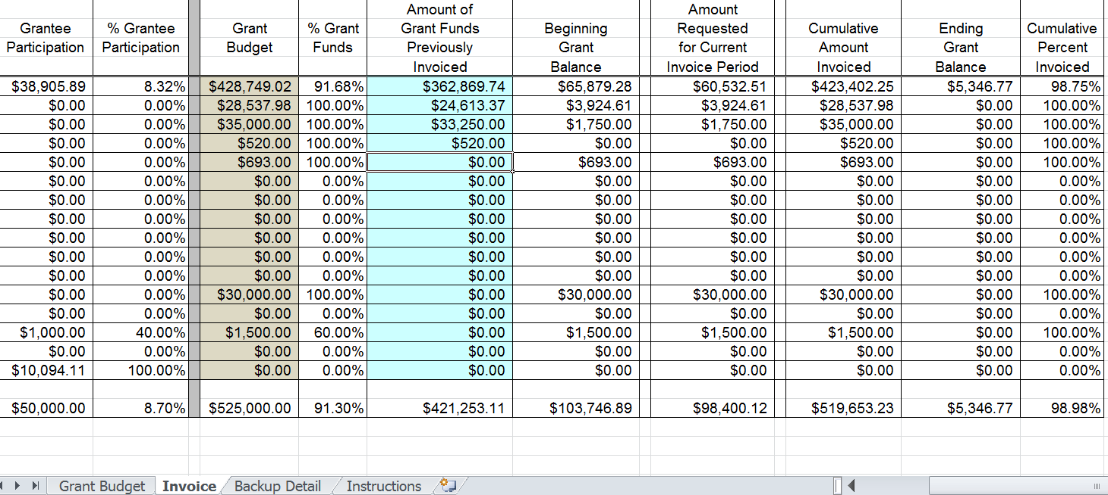
Image 6B
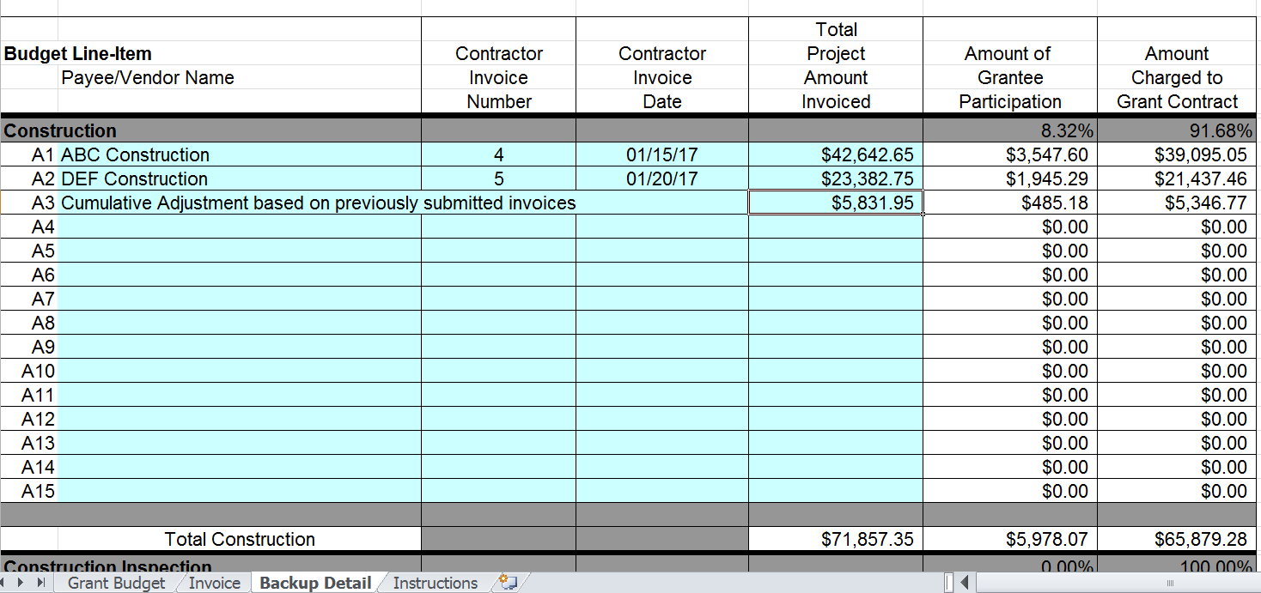
Image 6C
