DBE INTERESTED PARTIES LIST SIGN-UP PROCEDURES
The DBE Interested Parties List is provided as a service of the TDOT Small Business Development Program to help prime contractors know which DBEs have expressed an interest in bidding on specific contracts for each Letting. If you are a DBE and want to be added to this list, please follow these steps:
- Review the Notice to Contractors on the TDOT Construction Division website
  - Identify each contract number/county of interest
- On the page for the upcoming Letting, go to the “Quantities” link
  - Scroll to each job you are interested in working and find the item # you would like to work on and for which you are certified for goal credit
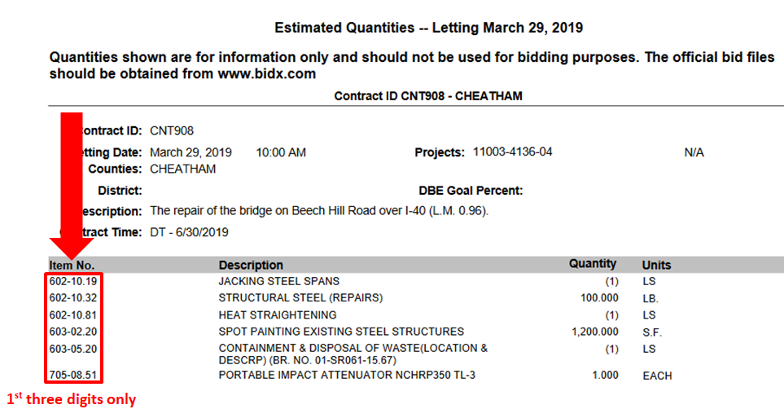

- Complete the DBE Interested Parties List Form (next page) with company name/email address, along with county, contract # and work item code(s)
The form should be completed and returned to TDOT.DBE.Program@tn.gov by the dates shown below. Late submissions will not be included on the website.
LETTING DATE | FORM COMPLETION DEADLINE
May 10, 2019 | April 24, 2019
June 21, 2019 | June 5, 2019
August 9, 2019 | July 24, 2019
October 4, 2019 | September 18, 2019
December 13, 2019 | November 27, 2019

DBE INTERESTED PARTIES LIST FORM

- Complete the form and save as a Word document
- Email the form to TDOT.DBE.Program@tn.gov by the dates listed on the previous page

DBE Company Name
Email Address

County Name (Location of Project) | Contract # | 3 Number Work Item Code(s)

