Business Process Improvement Plan

[Agency]
[Project Name]

Table of Contents
Using this Template 1
Revisions 2
Introduction 3
Purpose and Objectives 4
Organizational Goals and Objectives 4
Process Inventory 5
Create the “As Is” Flow Chart and Process Description 5
Current Business Process Description “As Is” Example 6
Future Business Process Description “To Be” 7
Recommendations 10
Processes for Immediate Implementation 10
Processes Needing Automation to Implement 10
More Information On BPI 11
Acceptance 12

Using this Template
This template contains “suggested language” and assumes that the author of this document will make appropriate additions, deletions, and changes for their specific project needs.

To create a document from this template:
- Replace [bracketed text] on the cover page, in the header, and throughout the document with your project and agency information by filling in the [bracketed text] area in the document text. Filling in the information once will propagate that field throughout the document.
- Complete the entire template making all necessary adjustments.
- Each section contains abbreviated instructions (Green Font) and an example using (Black Font).
- Delete this “Using This Template” page.
- Update the Table of Contents by clicking on the “References” tab, selecting “Update Table”, then “Update Entire Table” and click “Ok”.
- Save.

To provide any suggested improvements or corrections, please email TBSM.info@tn.gov.

Revisions
Revision | Description of Change | Author | Effective Date
v1 | Initial development | BSD Team | 10/18/2012
v2 | First draft revisions | J. Noonan | 11/06/2012
v3 | Quarterly update | BSD Team | 03/26/2013

Introduction
Business Process Improvement (BPI) is defined as “the systematic examination and improvement of processes” or “Improving quality, productivity, and response time of a business process, by removing non-value adding activities and costs through incremental enhancements.”

The objectives for any BPI initiative are:
- Effectiveness – Does the process produce the desired results and meet the customer’s/client’s needs? Effectiveness focuses on the customers/clients and whether the process delivers what they want.
- Efficiency – Does the process minimize the use of resources and eliminate bureaucracy? Efficiency focuses on the employees responsible for the overall process, the workers in an Agency and how easily they can use the business process.
- Adaptability – Is the process flexible in the face of changing needs? Adaptability evaluates how easily you can modify the business process on the basis of changing business requirements.

BPI can be performed any time an organization sees a need to reduce waste and redundancy or to implement new strategic goals within the confines of budget limitations. The purpose of the Business Process Improvement template is to guide Business Analysts in performing this task as a project team embarks on creating a solution.

The scope of this document focuses on performing business process improvement during the Initiation Phase of a project prior to documenting requirements for an automated solution.

It is wise to conduct a BPI initiative for any processes which are targeted to be changed and/or replaced with a change in technology. Ideally, the strategic goals of the organization should drive BPI and the changes resulting from it before a technology solution is considered. The technology should support the business process much as the business processes should support the strategic goals of the organization.

If possible, it is ideal, as well, to implement process changes in advance of any technology initiative in order to gain benefit from the improved processes as well as reduce the impact of changing processes while adopting new technology simultaneously.

The Business Process Improvement Plan for the [Project Name] project establishes the activities, processes, and procedures to enable a technology solution that includes measures to create greater efficiencies in [Agency] before documenting requirements for such a solution.

Purpose and Objectives
This section of the Business Process Improvement Plan should document, at a high level, the overall approach for performing BPI and define the purpose of the plan itself in the delivery of a process improvement initiative. Note that you will likely have numerous processes to document. The purpose of this plan is to describe HOW these processes are documented, not to document the processes. Use the TBSM Process Inventory & Prioritization Template, Visio flowcharts, and the TBSM Business Process Description Template to fully document both “As Is” and “To Be” processes in your organization.

The purpose of this plan is to describe the process of documenting [Agency’s] business processes as they currently exist (“As Is”) and to create new processes (“To Be”) that will help the Agency meet its strategic goals. This document describes the process by which identified core business processes are prioritized, documented, mapped and examined for improvement opportunities.
The Business Process Improvement Plan will accomplish the following objectives:
- Provide an overview of the organization’s goals and objectives
- Identify “as is” core business processes, and
- Recommend improvements to core business processes (“to be”) in order to optimize the use of resources and identify where technology solutions must support these new processes.

Organizational Goals and Objectives
In this section document your organization’s strategic goals and objectives overall and then, more specifically, for selection and implementation of new technology (or business process improvement).

The strategic goals and objectives of the [Agency] are as follows:

- Decrease time to respond to citizen requests for XXX service by X%
- Reduce cost associated with processing XXX forms by $X
- Increase quality of XXX service by reducing errors from X to X within two years

The [Project Name] project is a technology modernization initiative that is anticipated to include upgrades of the current XXX system, including streamlining current processes via implementation of a workflow module. In addition, revenue generated through the fees associated with XXX service will flow from a new system into the current XXX revenue system automatically, reducing human error and redundant data entry by the Agency’s accounting personnel. Finally, data captured from citizen requests will be able to be accessed more quickly and will be used to pre-populate future requests for service, increasing accuracy and reducing time to respond for returning customers.

Process Inventory
“The process inventory is a list of the business processes that an Agency (Division, etc.) owns.” If such process documentation exists, it’s simply a matter of making a list of the processes which may be impacted by the project to which you’ve been assigned. If the documentation does not exist, you may need to create it by questioning various workgroups within the affected work area. Use the TBSM Process Inventory & Prioritization Template to record the processes you wish to capture and prioritize (TBSM – Process Inventory & Prioritization Template).

Following is a high-level list of processes performed by the [Agency/Division, etc.] which have direct impact on the strategic goals and objectives of the organization. Because there was little to no formal documentation of the business processes performed in [Agency/Division, etc.] interviews, job observation and question/answer sessions were held to gain a basic understanding of the processes, procedures and laws governing the organization. This list was reviewed and approved by [Sponsor Name].

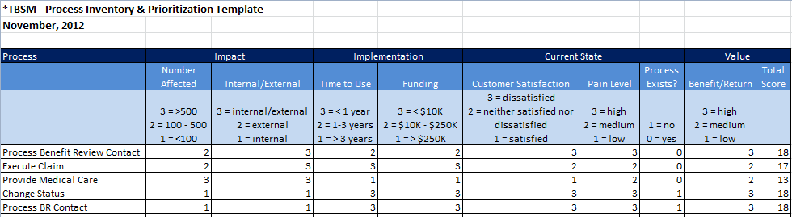

Create the “As Is” Flow Chart and Process Description
After working with the sponsors/personnel involved in the project to inventory and score the processes, work with the sponsor to determine the priority order in which processes should be examined. The first step, if the process is not already formally documented, is to document the current state (“as is”) before beginning the work to analyze the processes for improvement. It is also critical to set boundaries around the processes you will study – what is the beginning step in the process and what is the end; what sub-processes are included and not included in the BPI work? The TBSM Business Process Description Template is a guide to help formally document each business process. Along with this document, the Business Analyst will create a Process Flow Chart to graphically demonstrate the process flow, along with decision points, inputs, outputs, and responsible parties.

The Project Sponsor approved the prioritization of the processes documented in the Process Inventory and agreed that the following processes be documented for the [Project Name] project:

- Process Benefit Review Contact – begins with contact from an employee, employer or insurance carrier/administrator and ends with one of three resolutions: request for assistance, benefit review conference or request for settlement.

Current Business Process Description “As Is” Example
The purpose of the Business Process Description Template is to document one process at a time. Each process should have a clear beginning and an end and tie back to one of the overall Organizational Objectives.

Following is an example of the Business Process Description Template “As Is” for this project. The entire documentation is contained in X folder on the project’s share drive. There are X processes documented, both in flow charts and in narrative form.

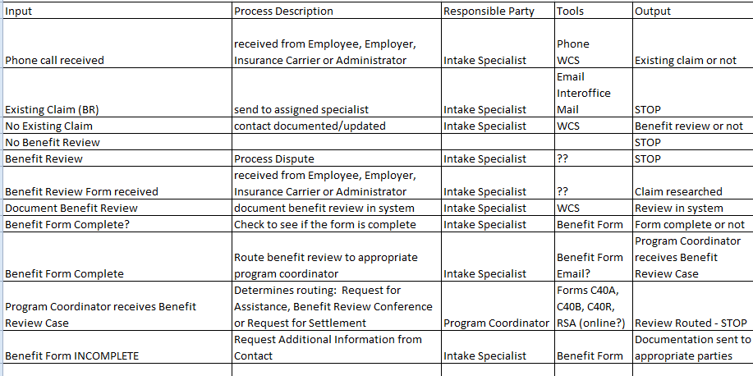

Future Business Process Description “To Be”
The purpose of this section of the document is to explain how the various business process improvement activities have resulted in modifications to the “As Is” processes. This section of the document also provides an example of a process that has been modified for the future, a.k.a. the “To Be”. The same Business Process Description template is used for documenting these processes as well. Again, each process should have a clear beginning and an end and tie back to one of the overall Organizational Objectives for the future state.

The project team, led by the Business Analyst, chose to hold focus groups of individuals intimately involved in each process to document potential modifications to the current processes to increase their effectiveness and efficacy. The focus groups used the following model to systematically examine each part of the business processes:

For each process, the focus groups considered the following concepts:
- Bureaucracy requires following a complex series of activities that hinders an effective and efficient process (example: multiple approvals). The cause of bureaucracy is often fear of making a mistake, the need for excessive control, a defensive move, or simply something that grew over time because “that’s how we always did it”. To eliminate bureaucracy, the team used two tactics. One was to ask “why” something had to be done. The other was to consider SALT. The team determined whether the activity supported Statutory, Audit, Legal or Tax requirements. If there was no good answer to either of these “filters”, the team eliminated the task.
- Value Added considers whether a task or activity adds value to a process by decreasing time to completion, improving quality or increasing customer satisfaction. If a particular task or activity did not add value to the process, the team eliminated the task.
- Eliminate Duplication is self-explanatory. Most often it takes actually drawing out a process, via flowchart, to see duplication of work, particularly when work occurs across groups or Agencies. Where possible, the team determined where the work should occur based on the objectives of the organization and then reworked the process to eliminate any duplication.
- Simplification, or streamlining the process, means reducing or eliminating the complexity of an activity in a business so that the process becomes easier to understand and more efficient. The focus group found many instances where a misunderstanding about why a piece of information was needed by another group allowed them to deliver the information in an easier to use and more straightforward way without impeding the intent of the process.
- Reduce Cycle Time fit well with some of the LEAN initiatives the Agency is conducting currently. Reducing cycle time is looking for ways to eliminate places where work is waiting to be done, or, as LEAN describes it, eliminating waste. The focus groups compared the cycle time (time it takes to accomplish an activity from beginning to the end) to the process time (time it actually takes without the waiting/waste). In this way, the team was able to reduce cycle time in many of our processes.
- Automation is always intended to make things faster, easier and more accurate. However, sometimes automation isn’t used appropriately and/or automation is not available to complete the task at hand. The Business Analyst warned the focus groups about jumping to Automation or technology as the solution before working through the other five techniques. In this way, the team was better able to target exactly what the new system requirements would be.

Following is an example of the Business Process Description “To Be”. The same template has been used to document all modified processes resulting from the business process improvement efforts the staff has completed.

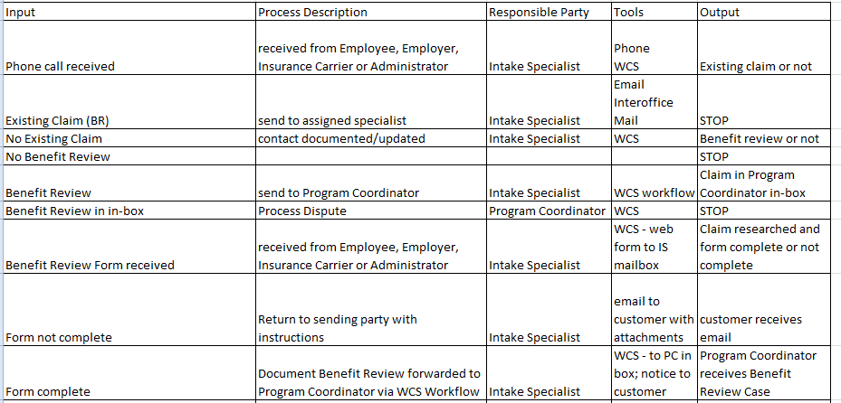

Recommendations

Processes for Immediate Implementation
A great benefit of going through the BPI process for our teams was that many of the improvement recommendations can be made immediately without waiting on the X Project to deliver a new system solution. The team recommends implementing the following revised processes as indicated below. We anticipate no change management issues (fallout) from implementing these two process changes.

- Change Status – requires no new/changed automation and no organization structure change/job change, just process change.
- Process BR Contact – requires Intake Specialists to enter several more data elements from Benefits form on screens they already visit. Adds 5 minutes to their processing time but reduces wait time for Claims Specialist review by 4 hours.

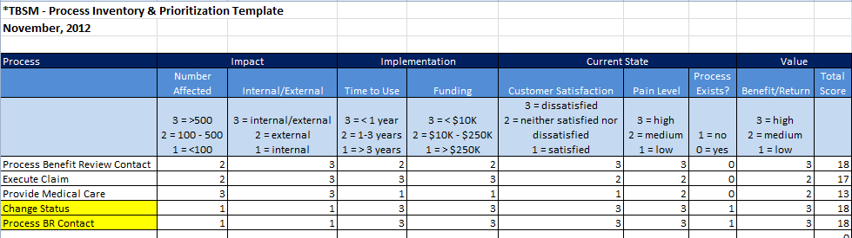

Processes Needing Automation to Implement
The team also identified processes that will require automation via the proposed new system. These have been documented as well and will form the basis of some of the Business Requirements documented in the Requirements Development Plan and Requirements Traceability Matrix. See the complete Process Inventory and Prioritization Template and the Business Process Description Template for details.

More Information On BPI
The State of Tennessee has embarked on improving processes in all Agencies via the use of an improvement concept called LEAN. There are multiple techniques available to use to streamline processes available via LEAN and all Agencies are working to name/assign LEAN coordinators who will facilitate those processes. LEAN tends to focus on one troublesome process at a time, not all of the processes in an organization holistically.

Business Process Improvement, however, is a more holistic approach, focusing on business processes that span groups, Agencies, stakeholders and provide multiple services for both internal and external customers. Because of its breadth, it is the chosen method for improving processes prior to large-scale, complex system procurement.

If you would like more information about LEAN, please contact Emily Passino at Emily.passino@tn.gov.

If you would like more information about Business Process Improvement, the following are references on the subject:

The Power of Business Process Improvement, Susan Page, American Management Association, 2010.

Extreme Government Makeover: Increasing Our Capacity to Do More Good, Ken Miller, 2011.

www.lean.org

Acceptance
(This section should be modified for best application to specific projects. Include all project team members that should have some level of authority regarding document review and approval.)

Approved by:

Date:
<Name of Approver>
[Project Name] Executive Sponsor

Date:
<Name of Approver>
[Project Name] Business Sponsor

Date:
<Name of Approver>
[Project Name] Project Director/Manager

Date:
<Name of Approver>
[Project Name] Stakeholder

The Power of Business Process Improvement, Susan Page, American Management Association, 2010, p. 1.
BusinessDictionary.com definition
Susan Page, p. 7
Susan Page, p. 19
Susan Page, p. 19
The Power of Business Process Improvement, Susan Page, American Management Association, 2010, p. 142
Susan Page, p. 146

