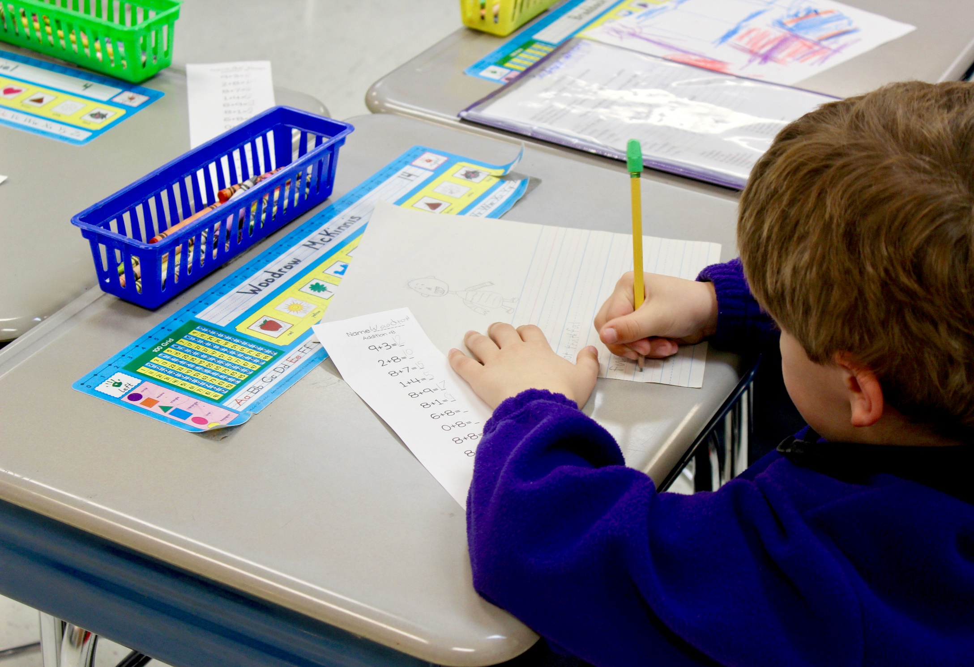

Trauma-Informed Discipline Practices
Guidance Document
Tennessee Department of Education | August 2019

Introduction
Chapter 421 of the Public Acts of 2019 directed the Tennessee Department of Education to develop guidance on trauma-informed discipline practices that districts must use to develop discipline policies that:
- balance accountability with an understanding of traumatic behavior;
- teach school and classroom rules while reinforcing that violent or abusive behavior is not allowed at school;
- minimize disruptions to education with an emphasis on positive behavioral supports and behavioral intervention plans;
- create consistent rules and consequences; and
- model respectful, non-violent relationships.

Balancing appropriate school discipline with school safety, classroom effectiveness, and positive outcomes for students can be a challenge. However, the benefits of using positive school discipline are many, including: students are more engaged and on task; classrooms are managed well; parents feel welcomed and are engaged; office disciplinary referrals, as well as suspensions and expulsions, reduced; academic achievement, attendance, and graduation rates improved.¹

In response to this directive, the department has conducted an extensive study of current research on adverse childhood experiences (ACEs) and trauma, the impact of trauma on classroom behavior, guiding principles in developing positive school discipline, and best practices for implementation to promote successful school discipline. The following are the results of that research, recommended guiding principles for developing trauma sensitive discipline policies, and best practices to utilize when developing discipline policies.

Impact of ACEs and Trauma on Behavior
Chronic childhood trauma, or what is commonly called ACEs, can disrupt a child's brain-building process. Like building a house in a storm or with below-grade materials and tools, ACEs are toxic to brain development and can compromise the brain’s structural integrity. Left unaddressed, ACEs

______________________________________
Treatment and Services Adaptation Center, What is a Trauma-informed School? from https://traumaawareschools.org/traumaInSchools
and their effects make it more difficult for a child to succeed in school, live a healthy life, and contribute to the state’s future prosperity — our communities, our workforce, and our civic life.²

Figure 1: ACEs
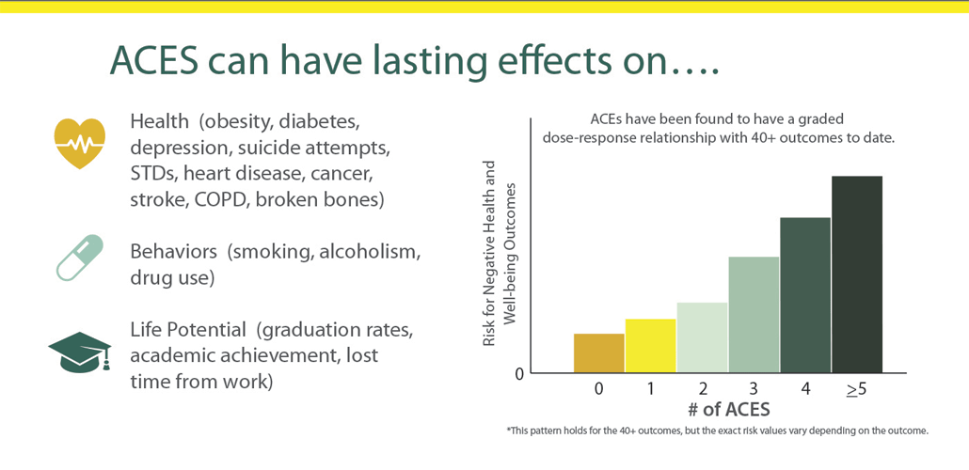
Source: Tennessee ACEs

Many children experience trauma through ongoing exposure to abuse, neglect, homelessness, domestic violence, or violence in their communities which can cause what’s known as toxic stress. This excessive activation of the stress response system can lead to long-lasting wear and tear on the body and brain. Children affected by trauma often exhibit:
- an inability to self-manage or regulate;
- have a lack of social and self-awareness;
- have poor relationship skills; and
- exhibit irresponsible or impulsive decision-making skills.

Trauma is particularly challenging for educators to address because children may mask their pain with behavior that’s aggressive, defiant, confusing, or out-of-proportion to the situation. The fight-flight-freeze response by students affected by trauma can manifest itself in observable behaviors such as hyperactivity, refusal to answer, running out of the classroom, or withdrawal. Identifying the symptoms of trauma in children can help educators understand those confusing behaviors and how to appropriately respond.

____________________________
² TN Department of Children’s Services, Tennessee ACEs, https://www.tn.gov/dcs/program-areas/child-health/aces.html
Impact of Exclusionary Discipline
Exclusionary discipline is any type of school disciplinary action that removes or excludes a student from his or her usual educational setting. Two of the most common exclusionary discipline practices are suspension and expulsion. Evidence does not show that discipline practices that remove students from instruction—such as suspensions and expulsions—help to improve either student behavior or school climate.³ Students with disabilities and students of color are generally suspended and expelled at higher rates than their peers.⁴

Figure 2: Results of Suspensions and Expulsions
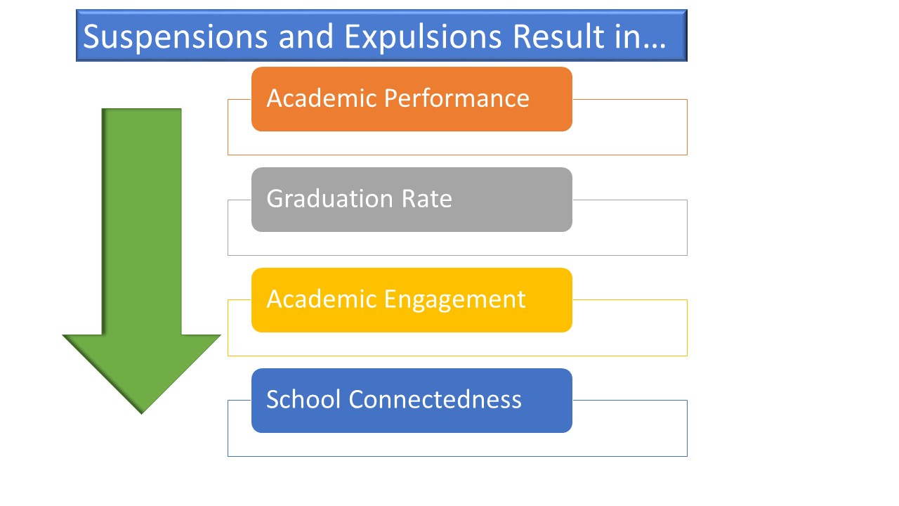
Source: Office of Civil Rights Data Collection, 2011-12

Discipline practices, such as restraint, corporal punishment, suspension, and expulsion, also have the potential to re-traumatize students. Schools participating in a trauma-informed approach in a multi-tiered system of supports (MTSS) should alter discipline practices for all students by decreasing the use of exclusionary discipline as a primary method of discipline. In order to help improve overall school climate and safety, schools should increase the use of positive trauma-informed strategies, such as positive behavior supports and restorative practices. School-wide and individual interventions that use proactive and preventive approaches address the underlying

_________________________
³ Helping Traumatized Children Learn, 2005
⁴ Skiba, Shure, Middelberg & Baker, 2011
cause (i.e. ,trauma) or purpose of the behavior and reinforce positive behaviors. These strategies have been associated with increases in academic engagement, academic achievement, and reductions in school dropouts and the use of exclusionary discipline.⁵

Guiding Principles
The goal of student discipline is to support students to behave in ways that contribute to academic achievement and school success and to support a school environment where students and staff feel safe physically, socially, emotionally, academically, and professionally. In all instances, school discipline should be reasonable, timely, fair, age and developmentally appropriate, logically connected to the particular behavior, relationally-based, and should match the severity of the student’s misbehavior. School discipline should be guided by the following principles: ⁶
- Effective and engaging instruction and classroom management are the foundation of effective discipline.
- School discipline is best accomplished by preventing misbehavior before it occurs and using positive, safe, and respectful interventions after it occurs. (Behavior Resources)
- Effective school discipline should hold students accountable without compromising school safety, respect, and dignity.
- Disciplinary actions should foster awareness of behavioral patterns and triggers and restore relationships with peers and adults in the school community.
- School safety is strengthened when all school staff build positive relationships with students and refer students to appropriate mental health supports when needed.
- Exposure to adversity and trauma may interfere with a student’s ability to regulate his/her emotions and behaviors, putting them at greater risk for disciplinary issues.
- School staff should understand the potential effects of adversity and trauma on student behavior and consider the reasons behind negative behaviors when determining disciplinary action.
- School staff should avoid re-traumatizing students by eliminating the use of potentially traumatic, violent, or shaming disciplinary practices.
- School discipline that offers students an opportunity to learn from their mistakes is more likely to result in getting the student re-engaged in learning.

__________________________________________

5 Treatment and Services Adaptation Center, What is a Trauma-informed School?, from https://traumaawareschools.org/traumaInSchools
⁶ Advancement Project, 2017
- Effective school discipline should minimize the amount of time students are removed from their classrooms due to misbehavior.

Best Practices to Promote Positive School Discipline
Positive, trauma-informed approaches to school discipline have been promoted as more effective alternatives to harsh and exclusionary discipline. Positive approaches emphasize strengthening, not lessening, the capacity of both school staff and students to establish and maintain safe, healthy, and supportive school climates to reduce and prevent inappropriate and disruptive student behavior.

Figure 3: Discipline Best Practices

Restorative Practices
Restorative practices have been proven effective in reducing misbehavior, bullying, violence, and crime among students while improving overall climate. Restorative practices is a framework, not a program. The framework is strengths-based, solutions focused, and all about relationship building. The fundamental hypothesis of restorative practices is that human beings are happier, more cooperative and productive, and more likely to make positive changes in their behavior when those in positions of authority do things with them rather than to them or for them.⁷ This hypothesis embodies the three principles of fair process: engagement, explanation, and expectation clarity. Recognized as a trauma-informed practice, restorative practices develop community and manage

________________________________
⁷ International Institute for Restorative Practices, 2018
conflict and tensions by repairing harm and restoring relationships. Examples of districts implementing restorative practices as a trauma-informed discipline practice are:
- East Tennessee:
  - Knox County Schools, Jeffrey Wright, special education specialist
- Middle Tennessee:
  - Metro Nashville Public Schools, Kyla Krengel, director of social emotional learning
  - Lawrence County Schools, Lawrence Public, Pam King, principal

Positive School Climate
School climate refers to aspects of the school environment that make students feel academically challenged, physically and emotionally safe, valued, and connected to their school settings. Positive school climate depends on the contributions of all members of the school community. A positive school climate is related to school success, and can improve attendance, achievement, graduation rates, and decrease discipline.⁸

Accurately measuring school climate helps schools identify areas of improvement and choose evidence based interventions for effecting positive change. The Tennessee School Climate Measurement System offers a free resource to schools and districts for measuring student, parent, and teacher perceptions of school climate. Survey results allow schools and districts to more clearly understand the relationship between positive school climate, academic outcomes, and discipline to make decisions regarding the allocation of limited resources and the effectiveness of various policies and practices in bringing about improvements.

The relationships between students, adults, and peers in a school play an important role in influencing positive school climate and the establishment of a nurturing environment of trust and respect. One of the most important roles that schools can play in the lives of students affected by trauma is helping them to have positive relationships with peers and adults. A student’s access to positive role models and ways of dealing with peers can play a major role in the healing process and lead to strong social, academic, and behavioral outcomes.⁹

_______________________________________
⁸ American Institutes for Research, National Center on Safe Supportive Learning Environments, https://www.air.org/center/national-center-safe-supportive-learning-environments-ncssle

⁹ American Psychological Association, 2008

Figure 4: Dimensions of Positive School Climate

Response to Instruction and Intervention-Behavior (RTI2B)
RTI²-B is an MTSS that offers a powerful, evidence-based approach for meeting the behavioral and social needs of students within an integrated, three-tiered model. Each tier of the framework involves careful reflection on the needs of students, the design of interventions matching those needs, and the collection of data to evaluate progress for individual students and for the school as a whole. When using positive behavior supports in all three tiers, schools create a culture where all students and teachers are respected. Schools selected as RTI²B model of demonstration schools through the Tennessee Behavior Supports Project can be found here:
- East Tennessee: https://etbsp.utk.edu/2017-model-of-demonstration-schools/
- Middle Tennessee: https://tennesseebsp.org/success-stories/school-exemplars/
- West Tennessee: http://www.tbspmemphis.com/mod

Behavior Intervention Plans (BIP)
A BIP is designed by school staff as an approach to correcting inappropriate or disruptive student behavior through positive behavioral interventions, strategies, and supports. A BIP describes the problem behavior, the reasons the behavior occurs, and the intervention strategies that will address the problem behavior. BIPs should also outline who is responsible for helping with each aspect of the plan, monitoring and making adjustments as needed. A BIP is appropriate for students with and without disabilities and can help support student’s development of desired behavior and reduce behaviors that are impeding their learning and participation.

Figure 5: Building Strong Brains
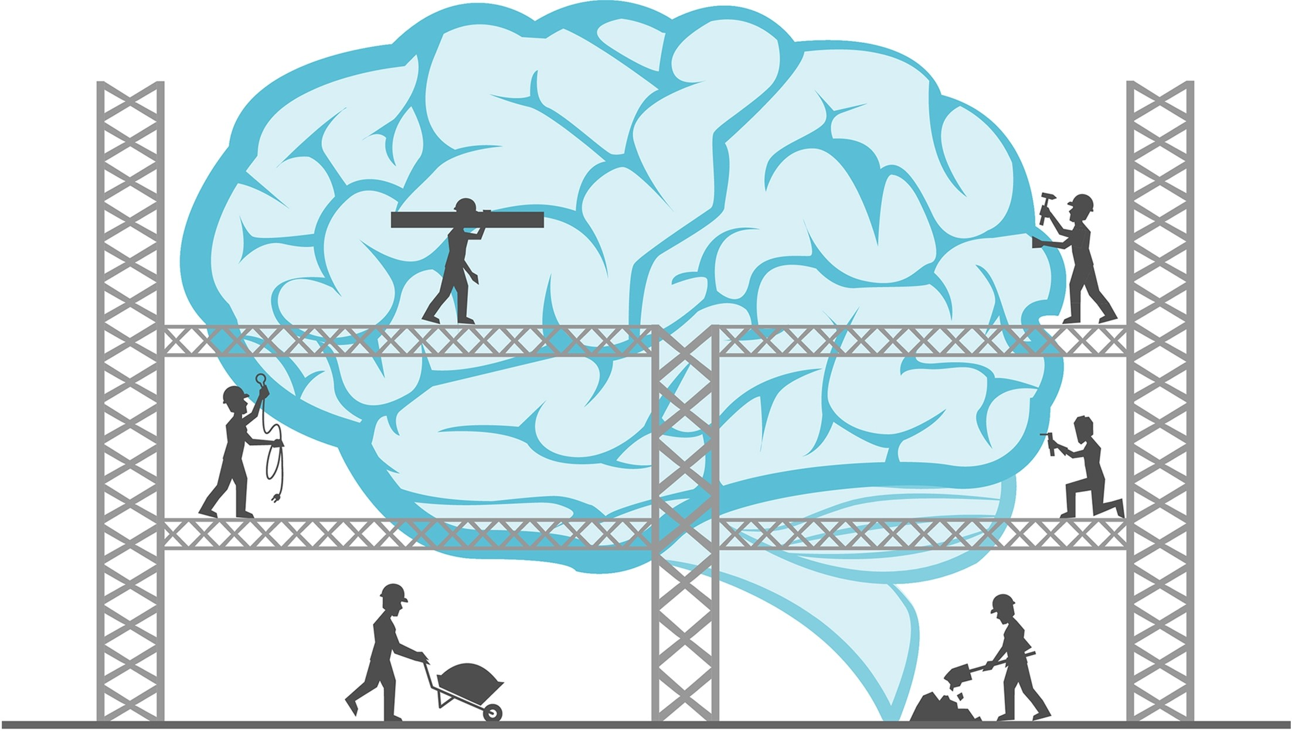
Source: TN ACEs Initiative

Building Strong Brains: Strategies for Educators Training
In 2016, the department implemented the Building Strong Brains: Strategies for Educators training program to empower educators to address ACEs and trauma in the school and classroom. Building Strong Brains provides educators with information on ACEs and trauma, the impact of ACEs and toxic stress on healthy development, how to respond versus react to challenging behaviors in the classroom, and trauma-informed principles and practices for the classroom and schoolwide.

Building Strong Brains recommends the following trauma-informed practices for implementation:
- Allow flexibility within predictable structure as a comprehensive school-wide approach.
- Promote and build supportive relationships between staff, students, families, and the community.
- Develop effective, positive school discipline that does not re-traumatize students.
- Build student capacity to address trauma, support regulation, and build resilience by teaching social and personal competencies.
- Empower students by offering choices and opportunities to participate and belong.
- Create a safe and welcoming climate for all students.

Creating a trauma-informed school is one in which all school administrators, teachers, staff, students, families, and community members recognize and respond to the behavioral, emotional, relational, and academic impact of traumatic stress on those within the school. By implementing trauma-informed practices, schools have the greatest potential to positively impact students, regardless of their trauma history. Trauma-informed practices are good for all students. A trauma-informed school is one where all students feel safe, welcomed, and supported. Examples of schools effectively implementing schoolwide trauma-informed practices are:
- East Tennessee:
  - Dogwood Elementary, Knox County Schools, Lana Shelton-Lowe, principal
  - Bowers Elementary, Roane County Schools, Brenda Arwood, principal
- Middle Tennessee:
  - Fall-Hamilton Elementary, Metro-Nashville Public Schools, Matthew Portel, principal
  - North Coffee Elementary, Coffee County Schools, Adam Clark, principal
- West Tennessee:
  - Tipton County Alternative Program, Tipton County Schools, Steve Zurhellen, principal

Conclusion

Though oftentimes challenging, schools must learn to balance appropriate school discipline with school safety, classroom effectiveness, and positive outcomes for students affected by trauma. Clearly defined and effectively communicated trauma-informed discipline practices are essential for a positive school climate and setting the tone for all behavior. When administrators, teachers, and staff understand and respond to those affected by trauma in positive, proactive ways, they help reduce trauma’s negative impact, support critical learning, and create a more positive school climate.

Resources

Tennessee Department of Education
The department has developed academic and non-academic supports for student to include:
- Behavior Resources: https://admincms.tn.gov/education/article/behavior
- Building Strong Brains: Strategies for Educators: Contact Pat.Conner@tn.gov
- Health and Safety: https://admincms.tn.gov/education/section/health-and-safety
- School Climate: https://admincms.tn.gov/education/topic/school-climate
- Social and Personal Competencies: https://www.tn.gov/education/health-and-safety/school-climate/social-and-personal-competencies.html
- School-based Mental Health Supports: https://www.tn.gov/education/health-and-safety/school-based-mental-health-supports.html
- Student Supports: https://admincms.tn.gov/education/topic/student-supports-in-tn

Collaborative for Academic, Social, and Emotional Learning (CASEL)
Leading organization in the U.S. advancing the development of academic, social, and emotional competence for all students.
http://www.casel.org

Edutopia
Provides resources for creating a healthy school culture by helping students develop skills to manage their emotions, resolve conflicts, and make responsible decisions.
https://www.edutopia.org/

International Institute for Restorative Practices (IIRP)
Conducts research and provides training for educators and other professionals on restorative practices.
https://www.iirp.edu/

Kidcentral TN
An online listing of state-operated and state-funded programs to find information and connect to thousands of programs available to Tennessee families, children, and parents.
https://www.kidcentraltn.com/

National Center on Safe Supportive Learning Environments (NCSSLE)
Provides resources and technical assistance to states, districts, and schools focused on improving student supports and academic achievement.
https://safesupportivelearning.ed.gov/

National Child Traumatic Stress Network
Raise standard of care and improve access to services for traumatized children, their families, and communities.
https://www.nctsn.org/

National School Climate Center
Promotes safe, supportive learning environments that nurture social and personal, civic, and academic growth for all students.
https://www.schoolclimate.org/

Positive Behavioral Interventions & Supports (PBIS)
Funded by the U.S. Department of Education, the technical center on PBIS supports schools and districts to build systems capacity for implementing a multi-tiered approach to social, personal, and behavior support.
https://www.pbis.org/

The Center on the Developing Child at Harvard
The mission of the center is to drive science-based innovation that achieves breakthrough outcomes for addressing ACEs.
https://developingchild.harvard.edu/

Trauma Sensitive Schools
Provides support to schools to become trauma-sensitive environments. https://traumasensitiveschools.org/

