TEACHING AS A PROFESSION (TAP)
__________

Education & Training
__________

Level Four
Level Three
Level Two
Level One
ABOUT THE PROGRAM OF STUDY
Dual credit/ dual enrollment options include:
Course A

Course B
Teaching as a Profession is designed for students interested in becoming a teacher, school counselor, librarian, or speech-language pathologist. While in this program of study, students will learn teaching and classroom management strategies, lesson planning, special populations, how to use educational technology, how to become a professional, and more! Upon completion of this program of study, students will have participated in an internship and built a professional portfolio that can be used for advanced training as future educators at the postsecondary level.

This is not an exhaustive list of all of the opportunities available in Tennessee.

CAREER OPPORTUNITIES

The Teaching as a Profession occupation group has a bright outlook statewide between 2014 and 2024. Job opportunities are strongest in urban, suburban, and northern areas of Tennessee. The job outlook for this program of study in Tennessee is as follows: 20 percent increase for elementary workers, 19.7 percent increase for middle school teachers, 12.8 percent increase for special education school teachers, and 14.2 percent increase for speech-language pathologists by 2024.

Employment Projections for Teaching as a Profession in Tennessee (2014-2024)
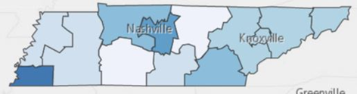

POSTSECONDARY OPTIONS
School | Degree Program
Nashville State Community College | Teaching or Early Childhood Education
Motlow State Community College | Teaching or Early Childhood Education
Volunteer State Community College | Teaching or Early Childhood Education
For more college and career planning resources, visit http://collegefortn.org.

Have you registered for the Tennessee Promise? Seniors enrolled in this program have the chance to attend a two-year program at a Tennessee College of Applied Technology (TCAT), community college, or some two-year university programs for free! To learn more, please see your school counselor or visit http://www.tennesseepromise.gov .
Teaching as a Profession Related Occupations with the Most Annual Average Openings in Tennessee (2014-2024)
Occupations | Total Percent Change | Median Salary
Elementary School Teachers, Except Special Education | 14.5% | $48,750
Educational, Guidance, School, and Vocational Counselors | 11.40% | $46,930
Secondary School Teachers, Except Special Education | 7.9% | $60,370
Middle School Teachers, Except Special Education | 15.00% | $47,940
Librarians | 10.10% | $51,300
Speech-Language Pathologists | 25.10% | $55,050
Teachers and Instructors, All Other | 13.30% | $43,300
Source: TN Dept of Labor & Workforce Dev, Div Emp Sec, R&S
Downloaded: 08/16/2017 11:11 AM

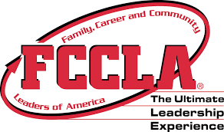
Students in this program of study will be eligible to join FCCLA, Family, Career and Community Leaders of America. In addition to school events, students will be able to compete at the district, state, and national level. Involvement in FCCLA offers students the opportunity to expand their leadership potential and develop skills for life—planning, goal setting, problem solving, decision making, and interpersonal communication—necessary in the home and workplace. Walk away from your high school career with experience in competing, networking, applying course content, and more! See your adviser to learn more about FCCLA or visit http://www.tennesseefccla.org.
For more information, contact:
School High School
County Name Schools
CTE Director: Name
Email
Instructor: Name
Email

