AVIATION FLIGHT
__________

Transportation
__________

Level Three
Level Two
Level One

ABOUT THE PROGRAM OF STUDY
Dual credit/ dual enrollment options:
- Course A
- Course B

The Aviation Flight program of study prepares students to be successful in a range of aviation careers, such as pilots, aircraft engineers, air traffic control specialists, aircraft mechanics, or airline statisticians. Course content covers the knowledge and skills of all aspects of flight needed to pass the Federal Aviation Administration (FAA) Private Pilot written exam, including aircraft structures, flight environment, procedures and regulations, aerodynamics of flight, judgment training, navigation, and communications. Upon completion of this program of study, students will be prepared to take the FAA Private Pilot written exam and will be able to advance more quickly through the training hours typically required to solo in an aircraft after graduating. Dual credit or dual enrollment opportunities may be established with local postsecondary institutions.
Career Opportunities

Occupation | Total Percent Change | Annual Avg. Openings
First-Line Supervisors of Mechanics, Installers, and Repairers | 6.3% | 335
First-Line Supervisors of Transportation and Material-Moving Machine and Vehicle Operators | 9.9% | 175
Transportation, Storage, and Distribution Managers | 8.0% | 130
Aircraft Mechanics and Service Technicians | 11.6% | 80
Airline Pilots, Copilots, and Flight Engineers | 60.4% | 45
Air Traffic Controllers | 17.1% | 40
Avionics Technicians | 38.5% | 30
Commercial Pilots | 11.0% | 20
Aircraft Cargo Handling Supervisors | 9.8% | 10

Aviation Flight Related Occupations with the Most Annual Average Openings in Tennessee (2014-2022)
CAREER OPPORTUNITIES
The air transportation workers occupation group is projected to grow by 32.5 percent in Tennessee between 2014 and 2022 with a total annual average of 165 openings. Employment of airline pilots, copilots, and flight engineer is expected to grow by 60.4% with 45 annual average openings projected per year. Growth is also anticipated for commercial pilots, yet this is a smaller occupation with 20 annual average openings expected. Additional opportunities for students in this program of study are available in air traffic control where 40 annual average openings are projected. The Memphis area was reported to have the highest concentration of employment of airline pilots, copilots, and flight engineers in May 2014 with 310 reported to be employed.¹

¹ Bureau of Labor Statistics, U.S. Department of Labor, Occupational Employment and Wages, May 2014, 53-2011 Airline Pilots, Copilots, and Flight Engineers. (2015, March 25) Retrieved February 26, 2016, from http://www.bls.gov/oes/current/oes532011.htm

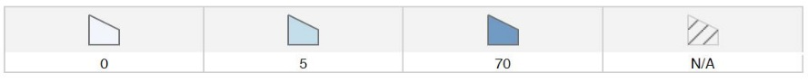
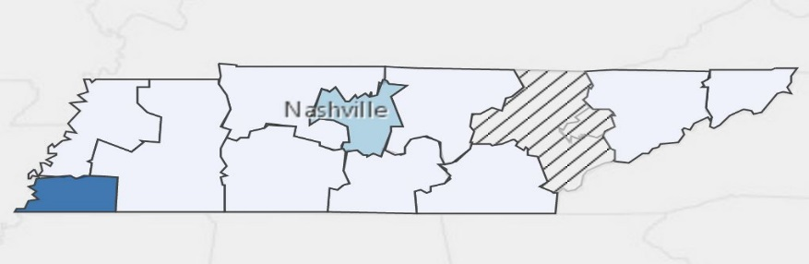
Annual Average Openings for Airline Pilots, Copilots, and Flight Engineers in Tennessee (2014-2022)
POSTSECONDARY OPTIONS

Source: TN Department of Labor and Workforce Development. (2015). Employment Security Division, Labor Market Information Section, on the internet at https://www.jobs4tn.gov/ (visited Feb. 25, 2016)
Have you registered for the Tennessee Promise? Seniors enrolled in this program have the chance to attend a two-year program at a Tennessee College of Applied Technology (TCAT), community college, or some 2-year university programs for free! To learn more, please see your school counselor or visit http://www.tennesseepromise.gov.

community college, or some 2-year university programs for free! To learn more, please see your school counselor or visit http://www.tennesseepromise.gov.

School | Degree Program
TCAT Memphis | Aviation Maintenance
TCAT Nashville | Aviation Maintenance
TCAT Morristown | Aviation Maintenance
For more college and career planning resources, visit http://collegefortn.org.

Students in this program of study will be eligible to join SkillsUSA. In addition to school events, students will be able to compete at the regional, state, and national level. Through SkillsUSA, students not only learn about aviation flight, but also professionalism, leadership, and workplace skills. Walk away from your high school career with experience in competing, networking, applying course content, and more!

For more information, contact:
Central High School
County Name Schools
CTE Director: Susan Smith Susan.Smith@school.edu
Instructor: Bob Johnson Bob.Johnson@school.edu

See your teacher to learn more about SkillsUSA or visit http://tnskillsusa.com/.

