CREATE SITE & PROGRAM - TENNESSEE
As part of the transition to Therap, providers will be entering their own Sites and Programs into the Therap system. This includes existing Sites upon initial set-up, as well as new sites. Only new sites approved by the DIDD Regional Offices should be created in Therap. DIDD issued Site Codes will be discontinued after July 1, 2024. After, July 1, 2024, approval of a site will be indicated by the issuance of an email from DIDD to the Provider agency indicating approval. Providers should continue to adhere to the Community Transition Policy for requirements related to licensing, home inspections, therapeutic site assessments, and other types of assessments required for physical moves.
This guidance applies to 1915c and Katie Beckett, Part-B Providers.

DEFINITIONS
Program: Provider agencies usually have a number of Programs to support groups of individuals they assist and provide services to. A Program is associated with one site, and each site may support multiple Programs.
Site: A site is a physical location, i.e., a building with a street address, for your Programs. Each site can be associated with multiple Programs.
Site Code: Refers to a number assigned to specific Sites. After, July 1, 2024, DIDD issued site codes will be discontinued.

ACCESS REQUIRED
Users with the Provider Setup administrative role can create, update, delete, deactivate, and activate sites and programs.

CREATE SITE

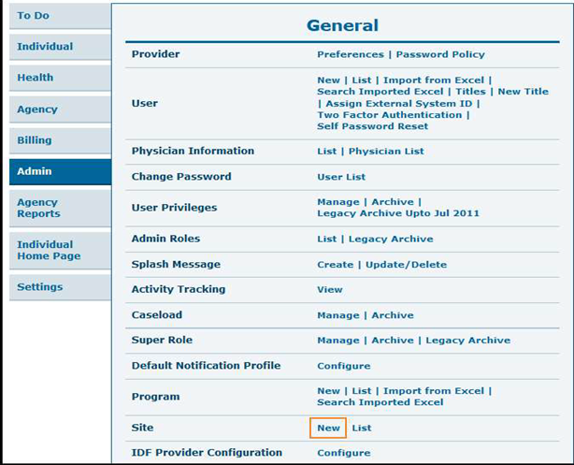
- Click on the New link next to the Site option on the Admin tab.

- Fill out the necessary fields on the 'Create New Site' page.
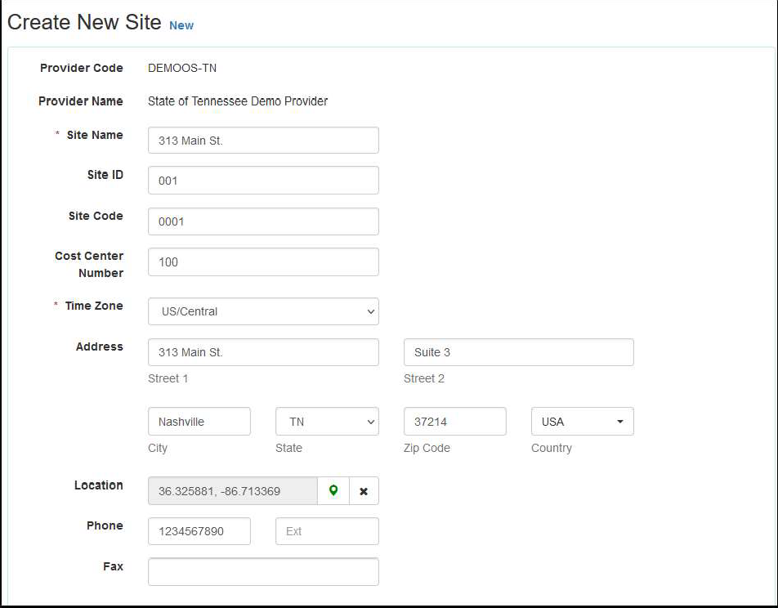

Site Name: Should be a street address associated with the Site.
- Each Site must have one address in the following format: Street 1 (Street number + Street Name), Street2 (Apt/Unit/Suite #), e.g., 123 Main St, Apt 12
  - Note: A single provider cannot use the same site name for two different sites.
- Site addresses must have a street address.
  - Do not use a P.O. Box.
  - Provider must verify that address matches USPS.com (ZIP Code™ Lookup | USPS)
- Providers should create Sites, only when approval from DIDD has been received.
Site ID: As per agency policy (optional)
Site Code: DIDD issued Site Codes will be discontinued after July 1, 2024.
With that in mind, this field will be optional, as per agency policy.
Cost Center Number: As per agency policy (optional)
Time Zone: Default as the Time Zone of the Provide Therap Account and may need to be changed.
Address: As per USPS specifications.
Location: Type in the address of the Site or select the Geolocation (optional).
Phone: If applicable, should be entered in xxxxxxxxxx or xxx-xxx-xxxx format
Fax: If applicable, should be entered in xxxxxxxxxx or xxx-xxx-xxxx format

- After filling out the relevant information, click on the Save button at the bottom of the form. You may create multiples new Sites by clicking on the Save And Create New button.

ADDITIONAL GUIDANCE
- For the establishment of new site (i.e., when a person transitions), Providers should create sites only after receiving an approval email from DIDD.
- Each Site must be licensed if applicable, or the agency must be licensed to provide the service.
- Supported Living and Semi-Independent Living Homes must have passed DIDD Home Inspection.
- If an individual moves from one Site to another, the transition must be approved by an appropriate regional DIDD transition unit before the Provider can create a new Site for the individual.
The following links to the Therap website provide guidance on updating, deactivating, and deleting sites.
- Update Site
- Deactivate Site
- Activate Site
- Delete Site

CREATE PROGRAM
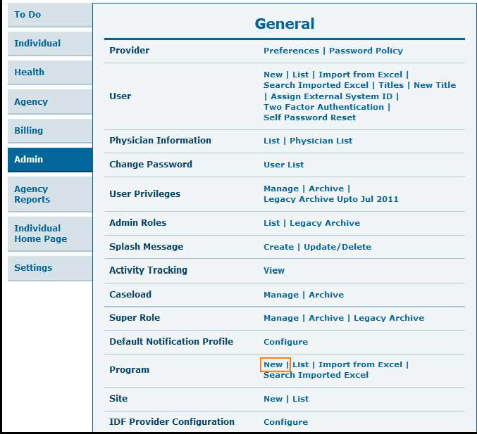
- Click on the New link next to the Program option on the Admin tab.
- Fill out the fields on the 'Create New Program' page as necessary.
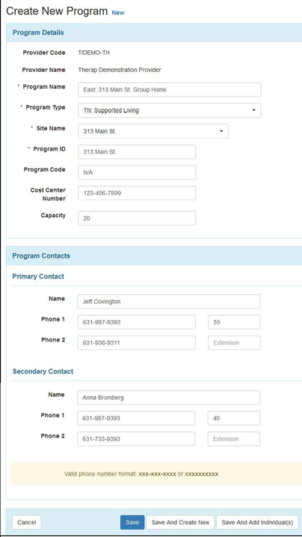
Program Name: Add TN Grand Region as prefix and name of the Program.
Program Type: There is a list of TN DIDD specific Program Types, please use TN to filter and find the most appropriate. Only use a Program Type
Site Name: Choose a Site that you have created and is associated with this Program. One Site can have multiple Programs.
Note: Every site under a program should be unique
Program ID: Repeat Address.
Program Code: As per agency policy (optional).
Cost Center Number: As per agency policy (optional).
Capacity: The number of individuals that are licensed for capacity (optional).
Primary & Secondary Contacts: As per agency policy (optional).

ADDITIONAL GUIDANCE
- Programs are tied to service authorizations.
The following links to the Therap website provide guidance on updating, deactivating, and deleting programs.
- Update/Delete Program
- Deactivate Program
- Activate Program

ENROLL INDIVIDUAL TO PROGRAM
- After filling out the relevant information for creating a Program, click on the Save And Add Individual(s) button to enroll individuals to the new Program.
- To enroll individuals to the program, use the filter under the 'Enrollable Individual(s)' section to search for an individual, and click on the Enroll link in row with the individual name.
If the individual cannot be found in the enrollable individual section, that means they have not been quick referred by DIDD. If this happens, please contact the appropriate regional office plan review inbox.
- East: DDETRO.CPC@tn.gov
- Middle: MTRO.Followup@tn.gov
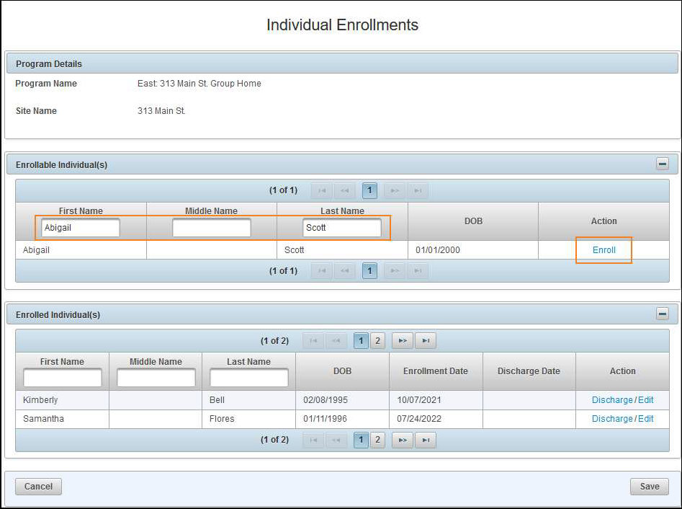
- West: west.service-request.followups@tn.gov
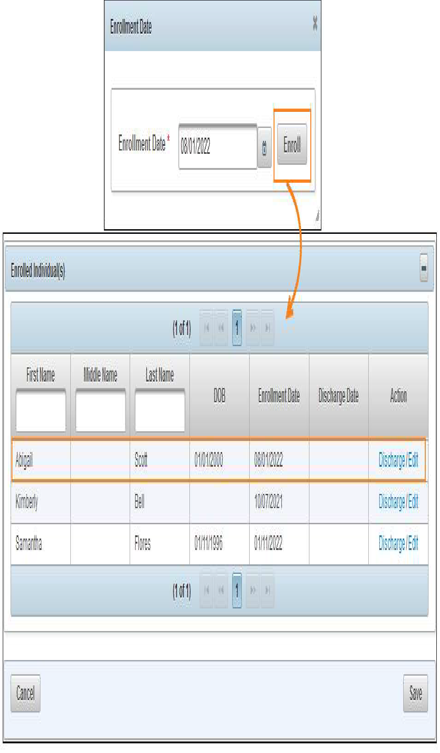
- On the ‘Enrollment Date’ popup window, enter the Enrollment Date and click the Enroll button. This will move the individual from ‘Enrollable Individual(s)’ to ‘Enrolled Individual(s)’ section to the ‘Enrolled individual(s)’ section.

- To enroll more individuals into this Program, you may repeat steps 2 and 3.

- Once completing enrolling individuals to the Program, click on the Save button located at the bottom of the page.
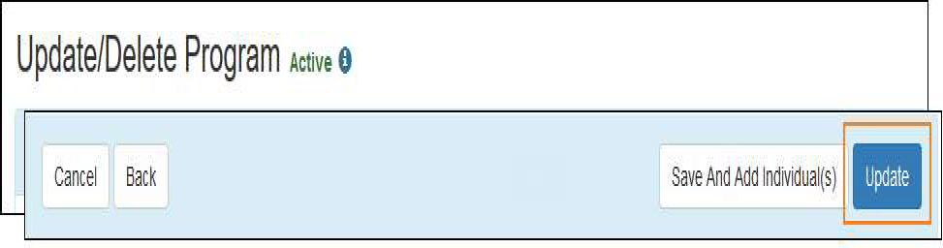
- You will be directed to the Update/Delete Program' page. Click on the Update button located at the bottom of the page.

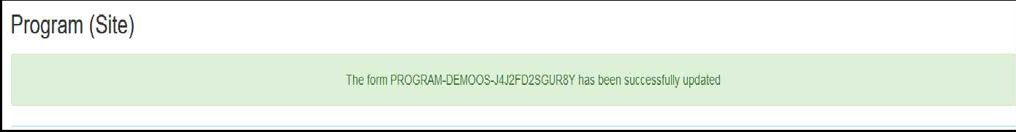
- A confirmation message will be displayed stating the Program has been successfully updated.

BULK ENROLLMENTS FOR MULTIPLE INDIVIDUALS
Providers and ISCs will need to have sites and programs set up and the individuals enrolled in order to acknowledge their service authorizations. In addition to setting up sites and programs, individuals must be assigned to those sites and programs ahead of the June bulk Service Authorizations date. Therap has functionality for enrolling multiple individuals into multiple programs. This can be done by importing program enrollment from excel. To learn more about this process click here.
Note: Users with the IDF Admin Administrative Role will be able to enroll multiple individuals into multiple programs.

